*­*

|  |  |
| --- | --- |
| *Pacific Gas and Electric Company* | |
| Release 9.0 Installation Guide | |
|  |  |
|  |  |
| Project | ED AM/GIS |
|  |  |
| Prepared by | Ashish Narasimham and Roger Carribine |
| Date | 9/17//2014 |
| Version | 1.01.0 |
| Version Type | Draft |

|  |  |  |  |
| --- | --- | --- | --- |
| Revision History | | | |
| Document # | Date | Author | Summary of Changes |
| 1.0 | 9/5/14 | Ashish Narasimham, Roger Carribine | Initial Document Creation |
|  |  |  |  |
|  |  |  |  |
|  |  |  |  |
|  |  |  |  |

# Introduction

## Purpose

This document is intended to detail the implementation and configuration steps required to implement Release 9.0 Installation Guide. This document describes the various configuration aspects required to complete any manual or automatic patch associated with this release. Each section in this document contains the steps required to patch the system in production.

## Terms Used

|  |  |
| --- | --- |
| OOTB | Out of the box. Unmodified from the commercial version. |
| TFS | Team Foundation Server |

## External Documents

Referenced are any external configuration documents or exports. These are documents that contain more detailed information about configuring a system or documents that can be loaded into an application to perform the configuration detailed in this document.

1. [Folder](\\\\sfetgis-nas01\\sfgispoc_data\\ApplicationDevelopment\\IBM_Delivery\\ReleaseInstructions\\9.0) containing all necessary files

## List of Fixes

Below is the list of change requests detailing all fixes for the data model for this release:

|  |  |
| --- | --- |
| **CR#** | **Title** |
| 16596 | Add new Subtype "Mesh Tie" to Tie Feature Class |
| 16698 | DM Change to EDGIS.Tie |
| 16510 | Differentiating Between Types of Cable |
| 16511 | Symbolizing a Cable with One Inactive Phase |
| 16308 | R3_BAY: New value/number for Domain: Device Group Type - Subsurface [S.F. PAR 61453] |
| 13832 | Add Antenna Feature Class |
| 14895 | New Secondary Voltage Domain Value |
| 16309 | Add DuctCount field to PGEDuctDefinition |
| 10594 | Update NeutralConductorAnno annotation expression |
| 13580 | Ground Switch Fields |
| 14249 | Add New Value to Conductor Type - UG Domain PAR #57706 |
| 17014 | PAR 71520: Add Values 25 - 40 to Conductor Count Domain |
| 17041 | Add support to place Neutral Conductor lines in ducts |
| 16529 | Move Position Description from Transformer Unit to Device Group |
| 17202 | Conductor cross section annotation |
| 14560 | R3_BAY: PAR #61652 -- T-Connector (Open Point Subtype) |
| 16514 | R3_BAY: Load Point To Service Location |
| 11977 | Add Encasement Size to Conduit |
| 7967 | R3_BAY: PAR 20907: Distribution Subsurface Transformer Device Group Structure Type Name Not In Drop Down |
| 16591 | Add new Device Group Type |
| 16491 | R3_BAY: PAR 64063: Transformer Overstriking in SFO |

## Summary of Steps to Complete Patch

These are the high-level steps to complete the installation and configuration of the data model patch. Use this table as a guide for completing the installation. Links are provided that can lead either within the document for detailed explanations or to external sites such as Sharepoint.

Table of Contents

1. Introduction 3

Purpose 3

Terms Used 3

External Documents 3

List of Fixes 4

Summary of Steps to Complete Patch 4

2. Open a Database Connection in ArcCatalog 7

3. 16596 - Add new Tie subtypes 8

4. 16510 - New FeederType field for CircuitSources 10

5. 16511 - Handle Dead Phases 15

6. 16308 - R3_BAY: New value/number for Domain: Device Group Type - Subsurface [S.F. PAR 61453] 19

7. 13832 - Add Antenna Feature Class 20

8. 14895 - New SL Value for Secondary Voltage Domain 29

9. 16309 - Add DuctCount to PGEDuctDefinition 33

10. 10594 - Update Neutral Conductor Annotation Expression 35

11. 13580 - Ground Switch Fields 38

12. 14249 - Add New Value to Conductor Type - UG Domain PAR #57706 39

13. 17014 - PAR 71520: Add Values 25 - 40 to Conductor Count Domain 40

14. 17041 - Allow Neutral Conductor to be placed in Conduits 42

15. Allow Deactivated Line Segments to be placed in Conduit 49

16. Configure Annotation for Neutral and Deactivated Conductors 51

17. 16529 - Move Position Description to Device Group 61

18. Update the Primary Voltage domain 66

19. 14560 - R3_BAY: PAR #61652 -- T-Connector (Open Point Subtype) 68

20. 16514 - R3_BAY: Load Point To Service Location 69

1. Create TRANSFORMERGUID Field 69

2. Create Relationship Class Between Transformer and Secondary Load Point 70

3. Create SECONDARYLOADPOINTGUID Field 77

4. SLP->SL Relationship 78

21. Configure Neutral and Deactivated Conductor for UFM 85

22. Add Encasement Size to Conduit 98

23. SSL annotation for under ground secondary conductor 99

24. Add New Device Group Type 100

25. 7967 - R3_BAY: PAR 20907: Distribution Subsurface Transformer Device Group Structure Type Name Not In Drop Down 101

26. R3_BAY: PAR 64063: Transformer Overstriking in SFO 103

27. Add FacilityID to UFM Feature Classes 106

6. Set permissions on root level items 108

7. Update Data Model Version Table 110

Known Issues 111

# Open a Database Connection in ArcCatalog

1. Open ArcCatalog.
2. Within the Catalog Tree, expand “Database Connections” and open the active connection for this process. This is the connection that is referenced in the change request associated with this document (EDGIS<DB name in the format X#Y> )

# 16596 - Add new Tie subtypes

1. Expand the Electric Dataset, right click on the EDGIS.Tie feature class and select “Properties…”

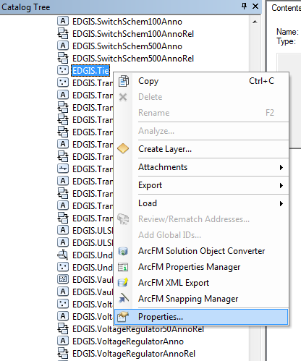

1. Select the “Subtypes” tab and in the “Subtypes” list, add the following entries:
2. Code: 3, Description: Mesh Tie
3. Code: 4, Description: Primary UG Tie

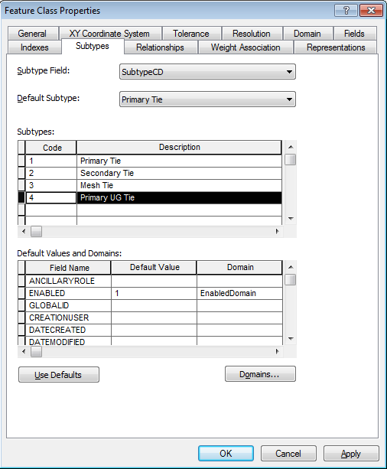

1. Select the description for the existing “Primary Tie” subtype and modify the entry to “Primary OH Tie”.

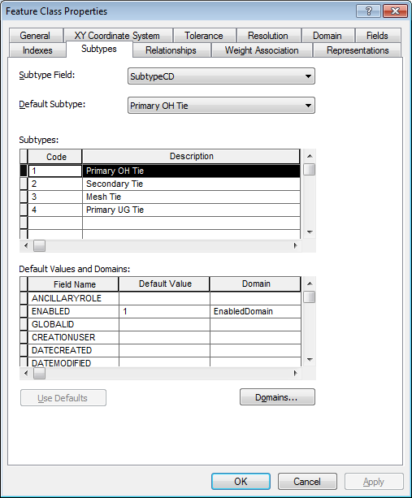

# 16510 - New FeederType field for CircuitSources

1. Right click on the database connection and at the context menu click on “Properties…”

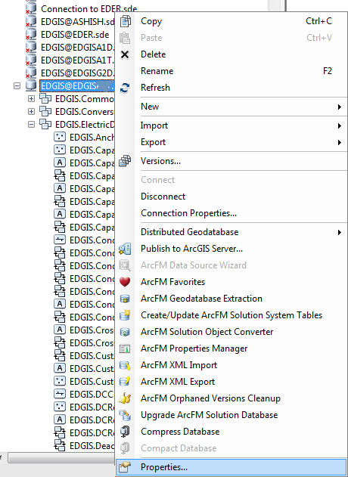

1. On the “Domains” tab, add a new Domain called Feeder Types with the following properties:
   1. Field Type: Short Integer
   2. Domain Type: Coded Values
   3. Split Policy: Duplicate
   4. Merge Policy: Default Value

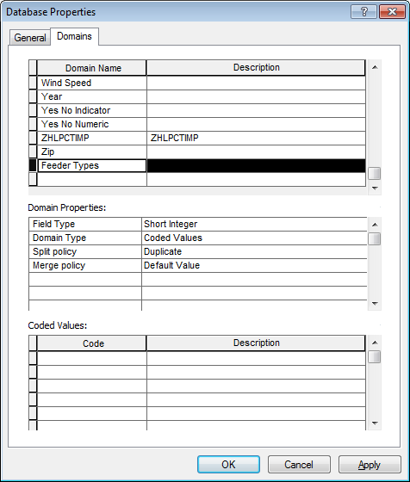

1. Add the following values to the new Feeder Types domain:
   1. Code: 1, Description: Tie
   2. Code: 2, Description: Network
   3. Code: 3, Description: Radial
   4. Code: 4, Description: Substation
   5. Code: 5, Description: Streetlight

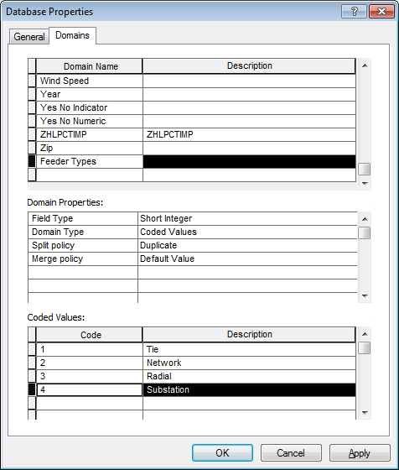

1. Right click on the EDGIS.CircuitSource object table and select “Properties…”

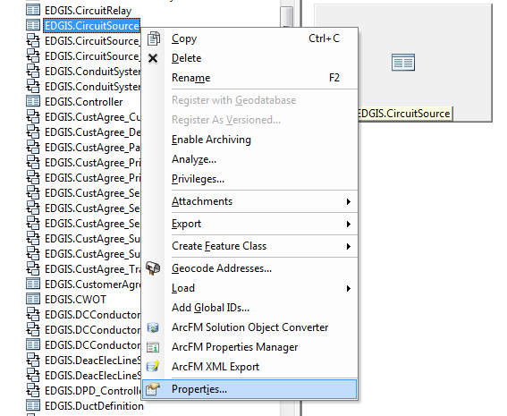

1. Add a new FEEDERTYPE field with the following properties:
   1. Alias: Feeder Type
   2. Type: Short integer
   3. Allow NULL values: Yes
   4. Domain: Feeder Types
   5. Precision: 0

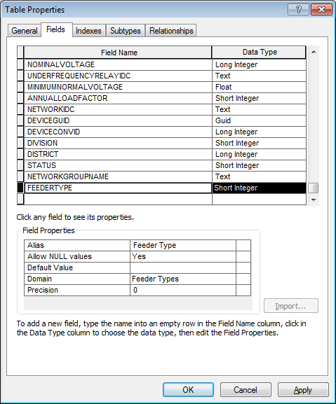

# 16511 - Handle Dead Phases

1. Right click on the database node and select “Properties”
2. Add the PGE_DEADPHASEINDICATOR to the PGE ED Field Model Name Domain domain.

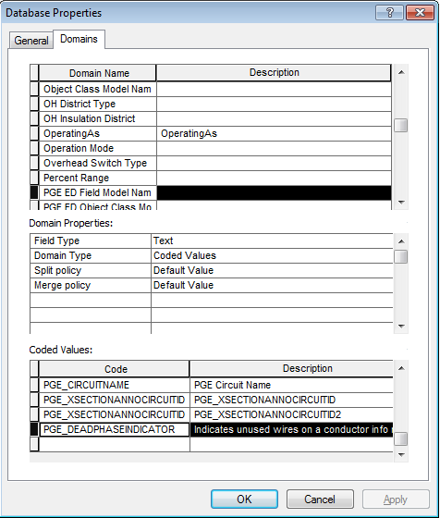

1. Right click on the “SecUGConductorInfo” object and click “Properties…”

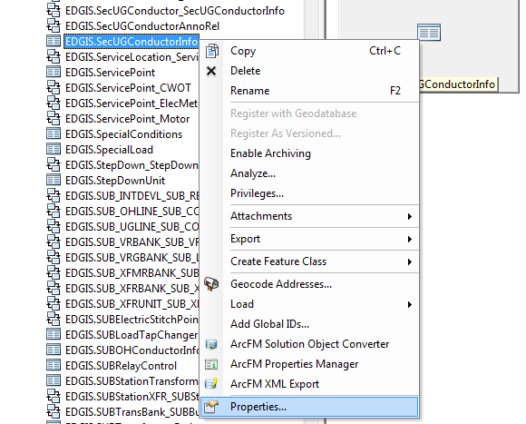

1. On the fields tab, add a new field “DEADPHASEIDC” with the following properties:
   1. Type: Text
   2. Alias: Has Dead Phase
   3. Allow NULL values: Yes
   4. Default Value: N
   5. Domain: Yes No Indicator
   6. Length: 2

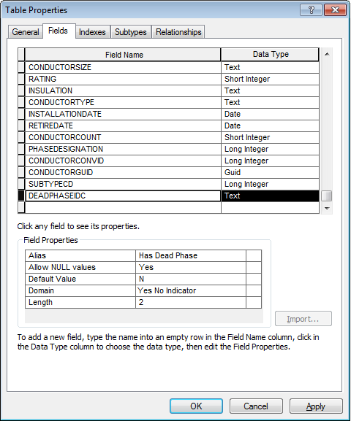

1. Right click on the “SecUGConductorInfo” object in the database and select “ArcFM Properties Manager”.
2. On the field model names tab, find the DEADPHASEIDC field and apply the PGE_DEADPHASEINDICATOR field model name to the field.

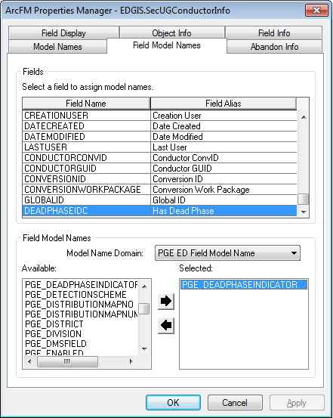

# 16308 - R3_BAY: New value/number for Domain: Device Group Type - Subsurface [S.F. PAR 61453]

1. Right click the database and select Properties.
2. Select the Domains tab and scroll down to the “Device Group Type – Subsurface” domain.
3. Select it and scroll to code=30. Modify it to “4kV Junction” as below:  
   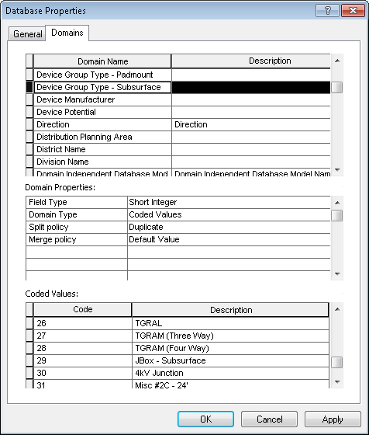

# 13832 - Add Antenna Feature Class

1. Go to the location referenced in Section 1.3 and copy the antenna.mdb file and antenna_model_props.xml file found in the folder locally.
2. Copy the feature class contained in the mdb into the Electric Dataset.
   1. To do this, first create a folder connection to the local folder and browse to it in ArcCatalog.
   2. Drag the feature class and drop it into the Electric Dataset.
3. Right click the Electric Dataset and select “Register as Versioned”.
4. Set permissions as follows:

assign privileges to all data in Electric Dataset of:

* SDE_EDITOR
* DAT_EDITOR
* DATACONV - select only
* DMSSTAGING - select only
* SDE_VIEWER - select only
* GIS_INTERFACE - select only
* GISINTERFACE - select only
  1. Do this by right clicking the Electric Dataset and selecting Privileges. Assign them as stated above.

1. Create a temporary version as EDGIS and log into the database using that version.  
   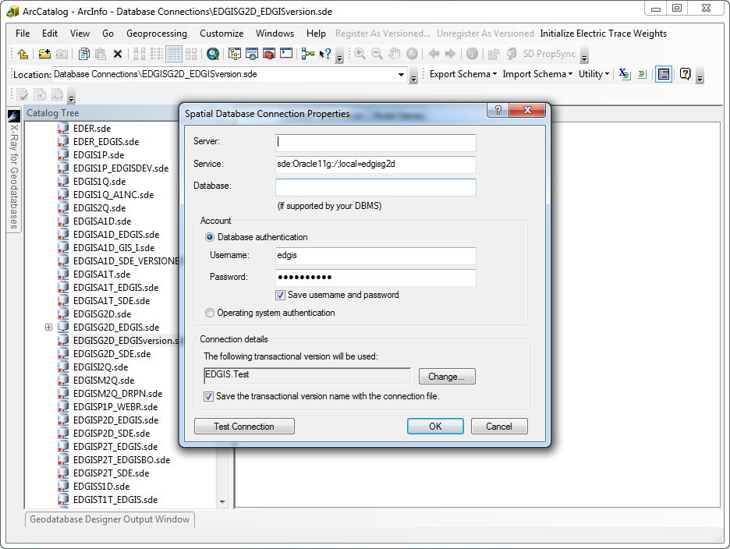
2. Right click the database root and select ArcFM XML Import.
3. Select the ‘Overwrite’ option.
4. Click browse and select the XML file that you copied locally.
5. Select Import to import the properties.
6. Verify that the feature class’s fields and properties match up with the below table.

|  |  |  |  |  |  |  |
| --- | --- | --- | --- | --- | --- | --- |
| **Field** | **Alias** | **Data Type** | **Size** | **Domain** | **Default** | **Nullable** |
| OBJECTID | OBJECTID | Object ID |  |  |  | N |
| CREATIONUSER | Creation User | Text | 15 |  |  | Y |
| DATECREATED | Date Created | Date |  |  |  | Y |
| DATEMODIFIED | Date Modified | Date |  |  |  | Y |
| LASTUSER | Last User | Text | 15 |  |  | Y |
| CONVERSIONID | Conversion ID | Long Integer | 10 |  |  | Y |
| CONVERSIONWORKPACKAGE | Conversion Work Package | Text | 6 | Conversion Work Package |  | Y |
| STATUS | Status | Short Integer | 2 | Construction Status |  | Y |
| INSTALLATIONDATE | Date Installed | Date |  |  |  | Y |
| LOCATIONID | Location ID | Text | 20 |  |  | Y |
| SYMBOLROTATION | Symbol Rotation | Double | 38,8 |  |  | Y |
| INSTALLJOBPREFIX | Job Prefix | Text | 3 | JobPrefixCode | PM | Y |
| INSTALLJOBYEAR | Year Installed | Short Integer | 4 |  |  | Y |
| LOCATIONDESC | Location Description | Text | 100 |  |  | Y |
| COMMENTS | Comments | Text | 255 |  |  | Y |
| COUNTY | County | Short Integer | 5 | County Name |  | Y |
| ZIP | ZIP Code | Text | 10 |  |  | Y |
| SUBTYPECD | Subtype | Long Integer | 10 |  | 1 | Y |
| LOCALOFFICEID | LOCALOFFICEID | Text | 4 | Local Offices |  | Y |
| DISTRICT | District | Long Integer | 10 | District Name |  | Y |
| DIVISION | Division | Short Integer | 5 | Division Name |  | Y |
| REGION | Region | Text | 10 | Region |  | Y |
| INSTALLJOBNUMBER | Job Number | Text | 14 |  |  | Y |
| CITY | City | Text | 40 |  |  | Y |
| STRUCTUREGUID | STRUCTUREGUID | Guid |  |  |  | Y |
| SHAPE | SHAPE | Geometry |  |  |  | N |
| GLOBALID | GLOBALID | Global ID |  |  |  | N |
| NUM | Number | Text | 25 |  |  | Y |
| CUSTOMEROWNED | Customer Owned | Text | 5 | Yes No Indicator | N | Y |

1. Right-click on the Electric dataset and select New->Relationship Class

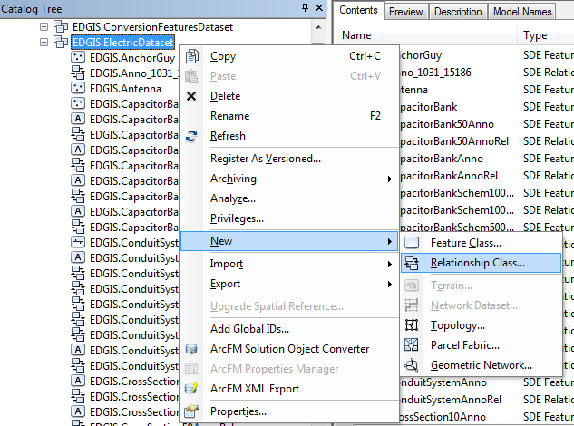

1. Specify the relationship name as SupportStruct_Antenna and select SupportStructure as the source and the new Antenna feature class as the destination.

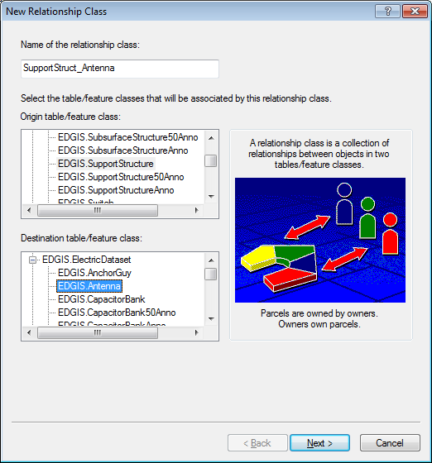

1. Select a Simple relationship and click next.

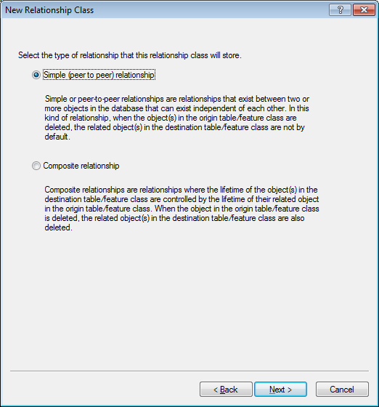

1. Select “Antenna” and “Support Structure” as the labels and specify “None” for messaging.

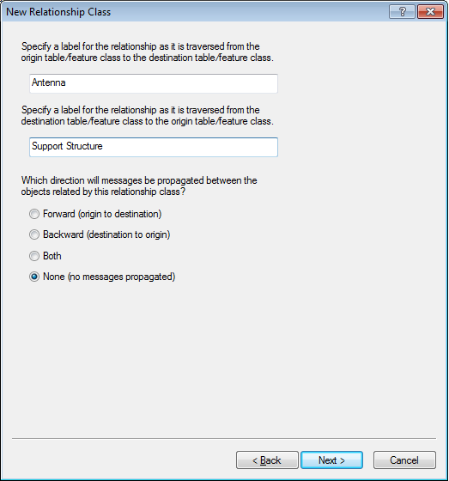

1. Select “1-M” for the cardinality and click next.

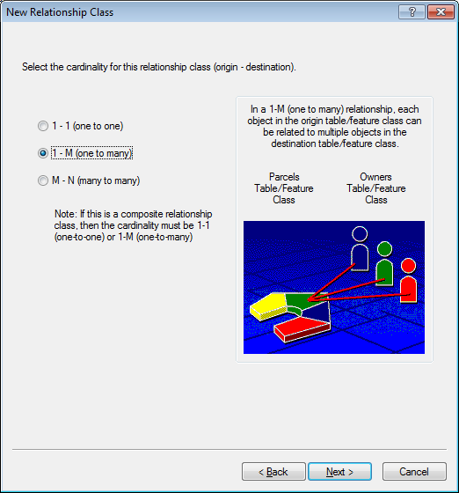

1. This relationship will not be attributed.

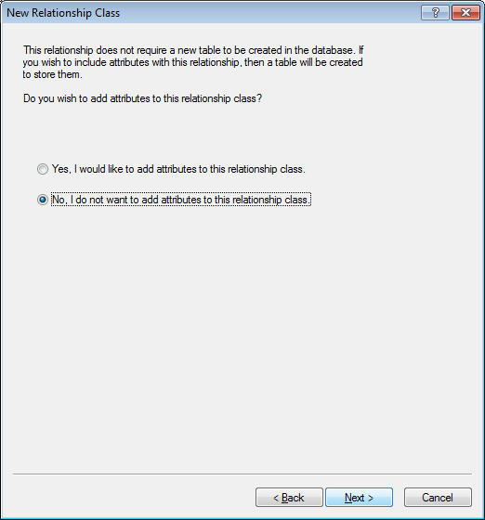

1. Specify the “GLOBALID” field as the primary key and the “STRUCTUREGUID” field as the foreign key.

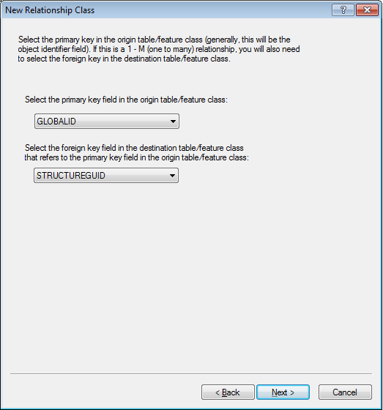

1. Review the summary and click Finish.

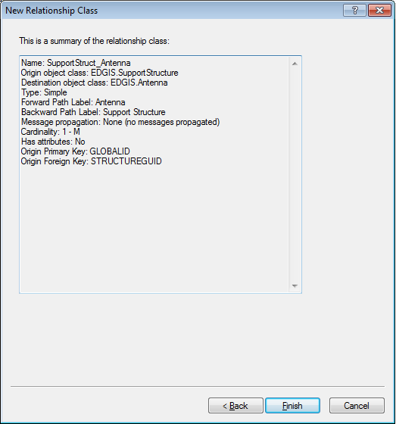

1. Right-click on the new Antenna feature class and select “ArcFM Properties Manager”.
2. In the Model Names tab, verify the following model names from the PGE ED Object Class Model Name domain:

PGE_ENFORCE_REGION

PGE_JOBNUMBER

PGE_VALIDATEREGIONALATTRIBUTES

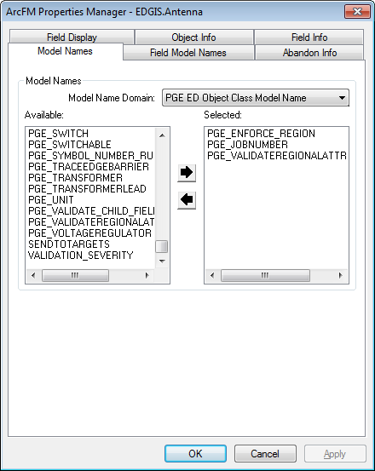

1. In the Field Model Names tab, verify the following field model names from the PGE ED Field Model Names domain:

|  |  |  |
| --- | --- | --- |
| **Field** | **Model Name Domain** | **Model Names** |
| SYMBOLROTATION | Domain Independent Field | SYMBOLROTATION |
| INSTALLJOBYEAR | PGE ED Field Model Name | PGE_INSTALLJOBYEAR |
| COUNTY | PGE ED Field Model Name | PGE_INHERITCOUNTY |
| ZIP | PGE ED Field Model Name | PGE_INHERITZIP |
| LOCALOFFICEID | PGE ED Field Model Name | PGE_LOCALOFFICE |
| DISTRICT | PGE ED Field Model Name | PGE_INHERITDISTRICT |
| DIVISION | PGE ED Field Model Name | PGE_INHERITDIVISION |
| REGION | PGE ED Field Model Name | PGE_INHERITREGION |
| INSTALLJOBNUMBER | PGE ED Field Model Name | PGE_JOBNUMBER |
| CITY | PGE ED Field Model Name | PGE_INHERITCITY |

1. In the Object Info tab, verify the following AutoUpdaters:

|  |  |
| --- | --- |
| **Event** | **AutoUpdater** |
| On Feature Create | PGE Populate Last Job Number AU |
| On Feature Create | ArcFM Structure Relate |
| On Feature Create | PGE Install Job Year |
| On Feature Create | PGE Inherit Regional Attributes AU |
| On Feature Update | ArcFM Structure Relate |
| On Feature Update | PGE Inherit Regional Attributes AU |

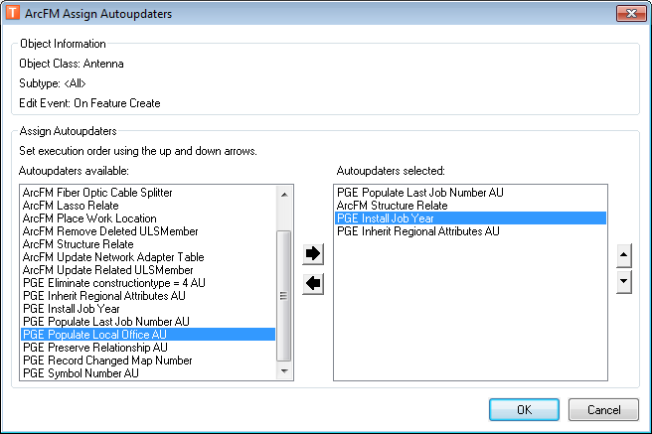

1. Verify the following Field AutoUpdaters

|  |  |  |
| --- | --- | --- |
| **Field** | **Event** | **AutoUpdater** |
| CREATIONUSER | On Feature Create | ArcFM Login User Name |
| DATECREATED | On Feature Create | ArcFM Current Date |
| DATEMODIFIED | On Feature Update | ArcFM Current Date |
| LASTUSER | On Feature Update | ArcFM Login User Name |

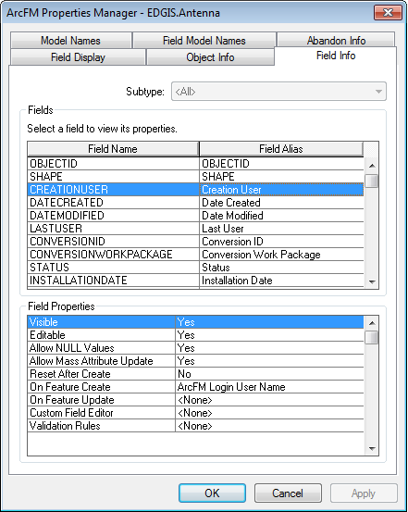

# 14895 - New SL Value for Secondary Voltage Domain

1. Right-click on the database level node and select Properties.

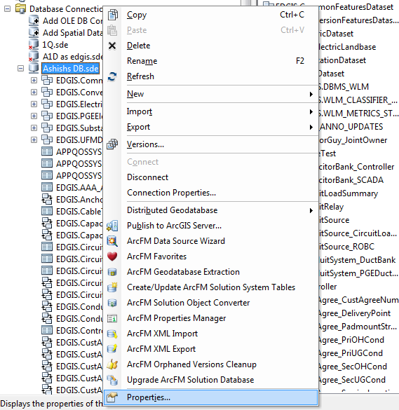

1. Select the Domains tab, find the Street Light Voltage domain and add the following entries:

Code:4000

Description: 4000V

Code: 5000

Description: 5000V

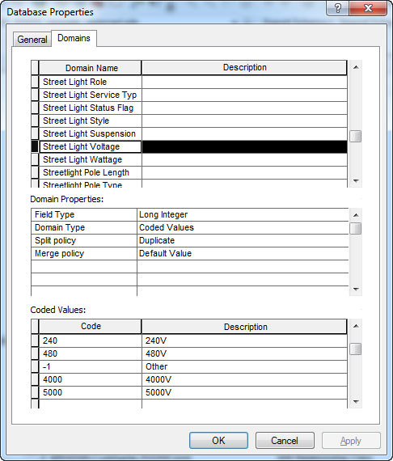

1. Double click the SecOHConuductor feature class and select the Subtypes tab.
2. Select the Streetlight Overhead Conductor subtype and scroll to the Operating Voltage field in the bottom window.
3. Assign the “Street Light Voltage” domain to it.  
   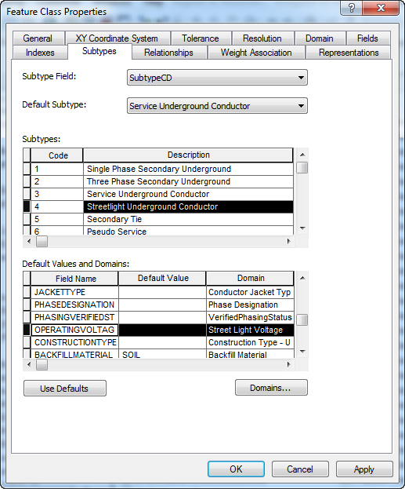
4. Select Apply.
   1. If you receive the following message:  
      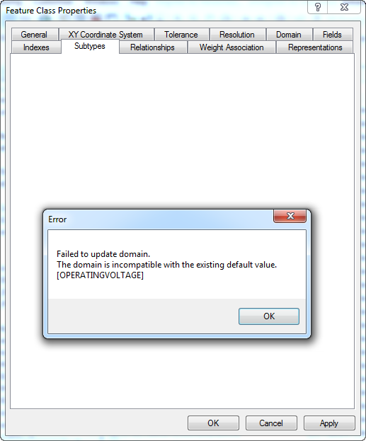
   2. Delete the value in the Default Value column of the field where you are setting the domain.
5. Repeat the above steps to assign the Street Light Voltage domain to the following feature classes and subtypes:

|  |  |
| --- | --- |
| **Feature Class** | **Subtype** |
| Transformer | Street Light |
| SecUGConductor | Streetlight Underground Conductor |

# 16309 - Add DuctCount to PGEDuctDefinition

1. Right-click on the PGEDuctDefinition table and select Properties.

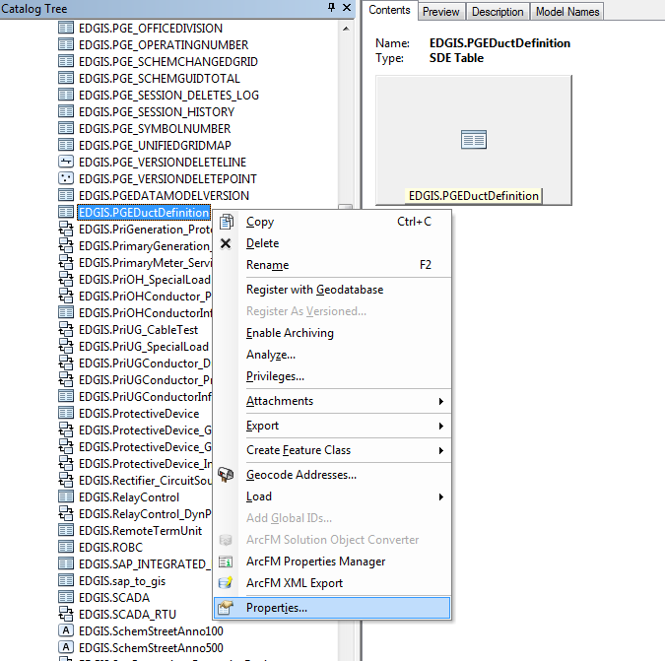

1. On the Field tab, add a new field as follows:

Name: DUCTCOUNT

Alias: Duct Count

Type: Short Integer

Precision: 2

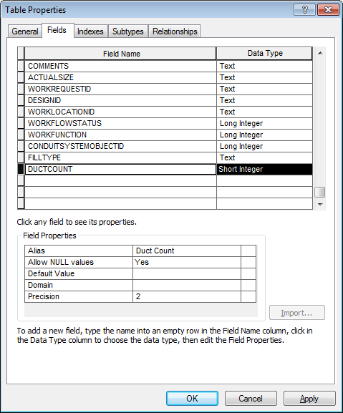

# 10594 - Update Neutral Conductor Annotation Expression

1. Right-click on the NeutralConductorAnno feature class and select Properties

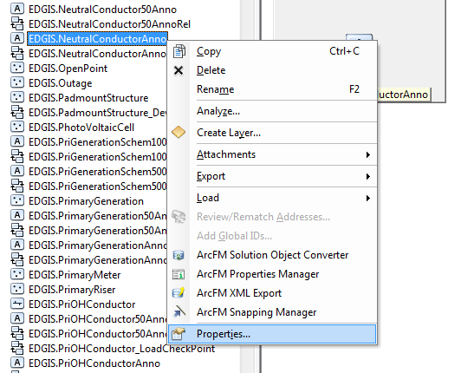

1. Select the “Annotation Classes” tab and click on “Expression…”.

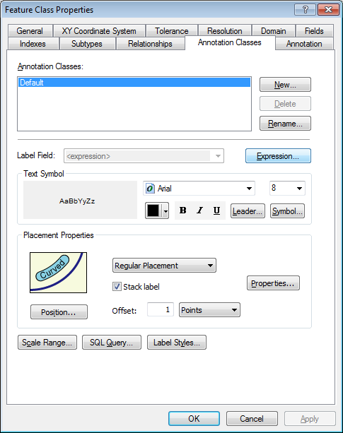

1. Update the expression as follows:

[LABELTEXT]

1. Repeat the process for the 1:50 annotation by right-clicking on the NeutralConductor50Anno feature class and selecting Properties.
2. On the Annotation Classes tab, click Expression and update the expression with the same value.

# 13580 - Ground Switch Fields

1. Double click on the TransformerDevice table in the root of the database.
2. Add the following fields with the following properties to the table:

|  |  |  |
| --- | --- | --- |
| Field | Alias | DataType (Size) |
| MAINWORKCTR | Main Work Center | Text (50) |
| LOCATION | Location | Text (50) |
| TECHIDENTNO | Tech Identity No | Text (50) |
| FEEDER | Feeder Name | Text (50) |

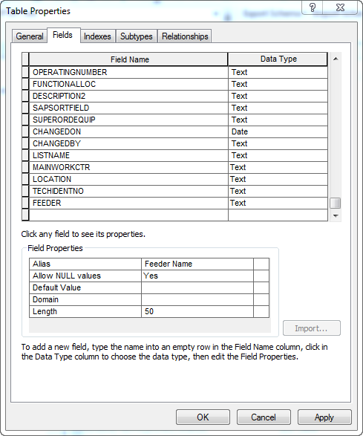

1. Click OK to accept.

# 14249 - Add New Value to Conductor Type - UG Domain PAR #57706

1. Right click the database->Properties to go to its properties.
2. Select the Domains tab and scroll to the “Conductor Type – UG” domain.
3. Put in the new code/value “Armour”/”Armour Cable” at the end of the list, like below.

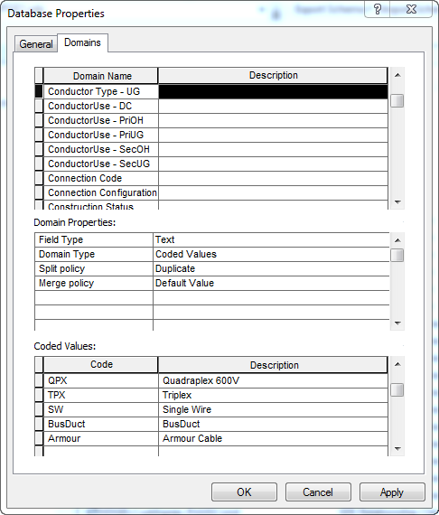

1. Click OK to accept.

# 17014 - PAR 71520: Add Values 25 - 40 to Conductor Count Domain

1. Right click the database to bring up the Properties window.
2. Select the Domains tab and scroll to the Conductor Count domain.
3. Scroll to the bottom of the domain and add the following codes/values:

|  |  |
| --- | --- |
| 25 | 25 |
| 26 | 26 |
| 27 | 27 |
| 28 | 28 |
| 29 | 29 |
| 30 | 30 |
| 31 | 31 |
| 32 | 32 |
| 33 | 33 |
| 34 | 34 |
| 35 | 35 |
| 36 | 36 |
| 37 | 37 |
| 38 | 38 |
| 39 | 39 |
| 40 | 40 |

1. The list will look as follows after you complete the above steps:

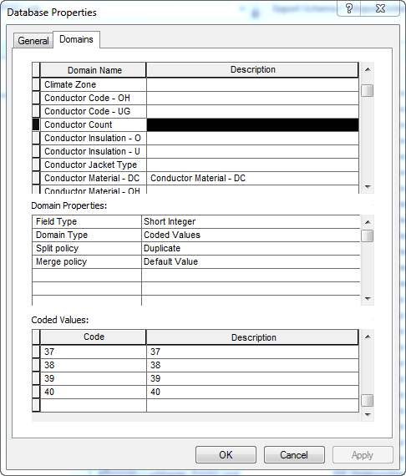

1. Select OK to accept.

# 17041 - Allow Neutral Conductor to be placed in Conduits

1. Right-click on the Electric Dataset and select New->Relationship Class

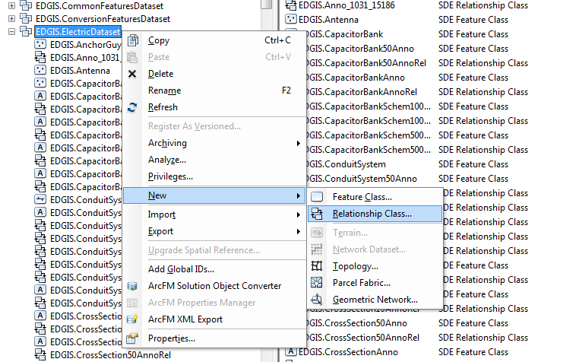

1. Give the new relationship a name of ConduitSystem_NeutralConductor and select the origin feature as ConduitSystem and the destination feature as NeutralConductor

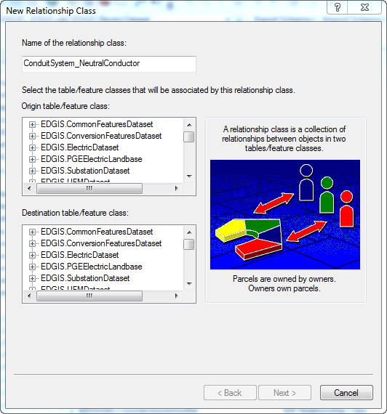

1. Specify a relationship type of Simple

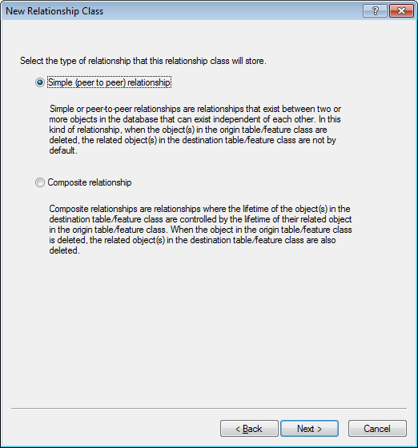

1. Give labels of “Neutral Conductor” and “Conduit System”

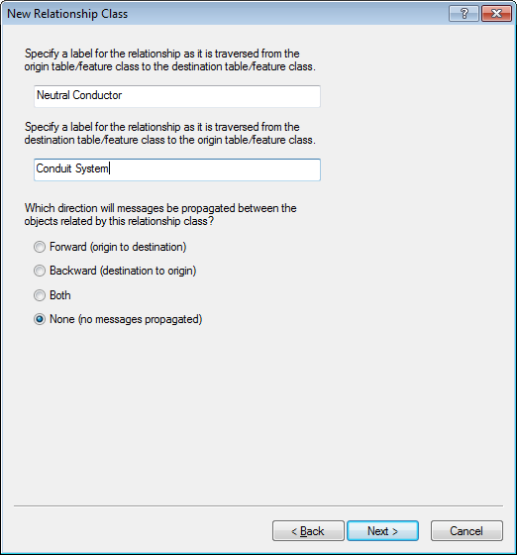

1. The cardinality will be M-N

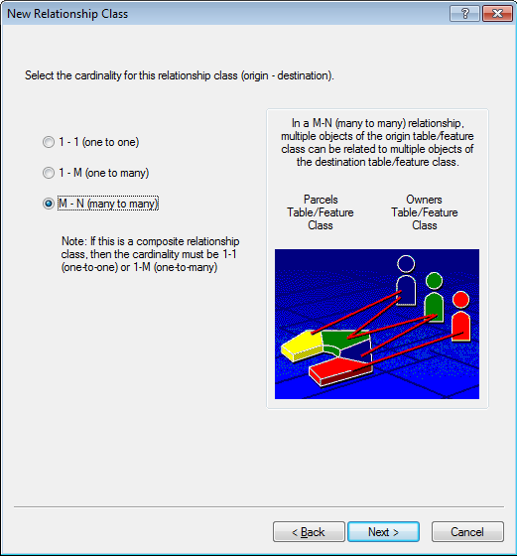

1. This relationship will be attributed

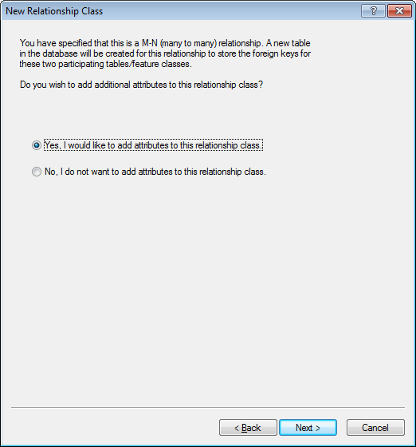

1. Add two attributes as follows:
   1. ULS_POSITION: Long Integer
   2. PHASEDESIGNATION: Long Integer

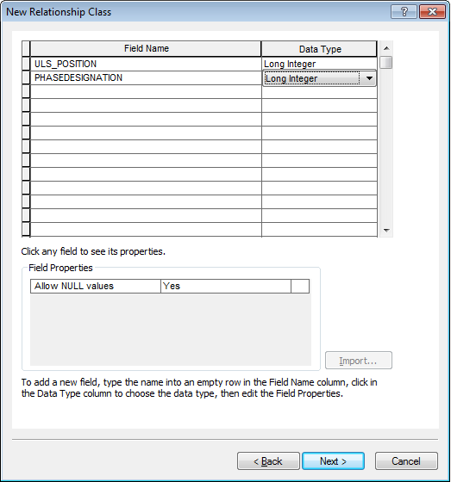

1. Specify the following key fields
   1. Origin Primary Key: OBJECTID
   2. Origin Foreign Key: ULSObjectID
   3. Destination Primary Key: OBJECTID
   4. Destination Foreign Key: UGObjectID

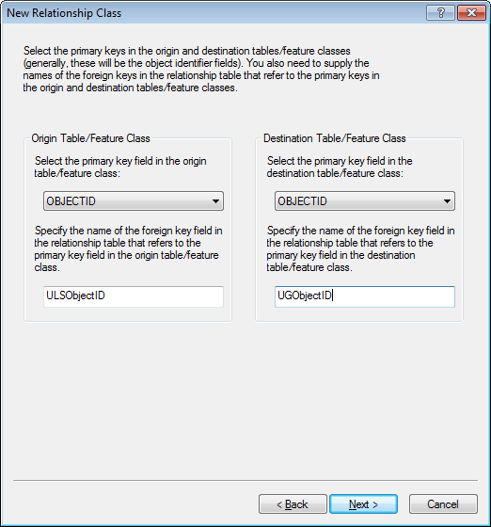

1. Review the summary and click Finish

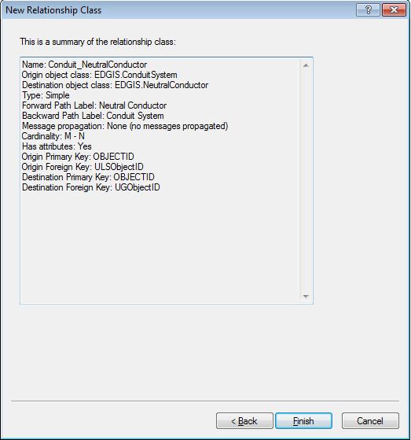

1. Right-click on the new ConduitSystem_NeutralConductor relationship class and click “ArcFM Properties Manager”
2. Assign the ArcFM Conduit to Conductor Composite AU for all three event types and click OK

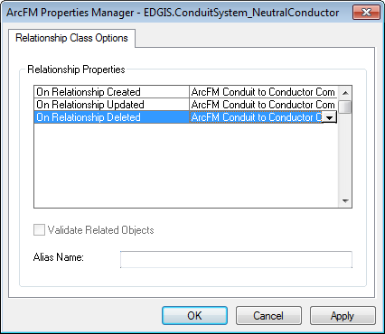

1. Right-click on the NeutralConductor feature class in the Electric Dataset and select “ArcFM Properties Manager”
2. On the Model Names tab, assign the ULSMEMBER model name and click Apply

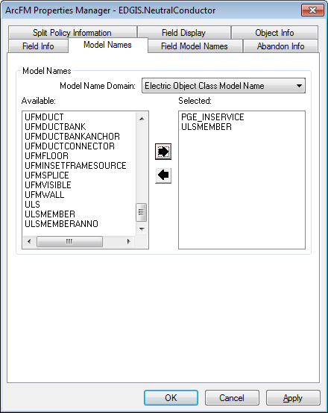

1. On the Object Info tab, assign the ArcFM Check Cross Section to the On Feature Update event and click OK

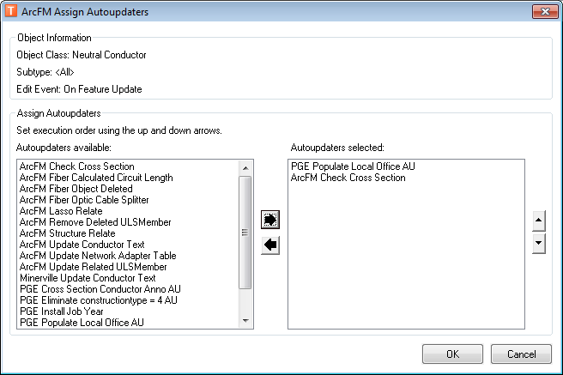

1. On the Object Info tab, assign the ArcFM Remove Deleted ULSMember AU to the On Feature Delete event and click OK

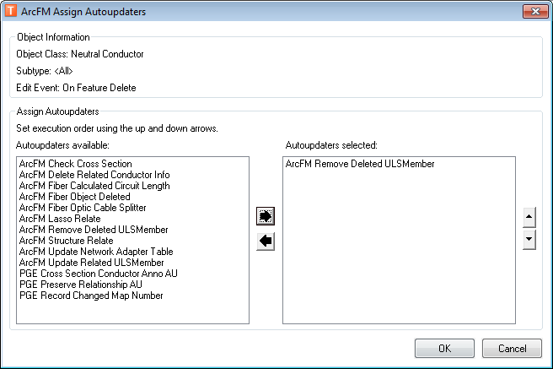

# Allow Deactivated Line Segments to be placed in Conduit

1. Right-click on the ConduitSystem_DeacElecLineSeg relationship class in the Electric Dataset and select “ArcFM Properties Manager”
2. Apply the ArcFM Conductor to Conduit Composite AU to each event.

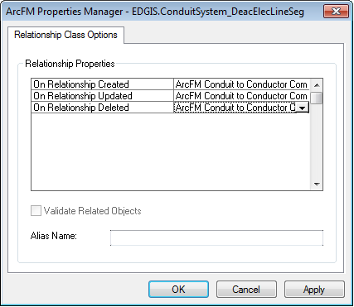

1. Right-click on the DeactivatedElectricLineSegment feature class in the Electric Dataset and select “ArcFM Properties Manager”
2. On the Model Names tab, assign the ULSMEMBER model name and click Apply

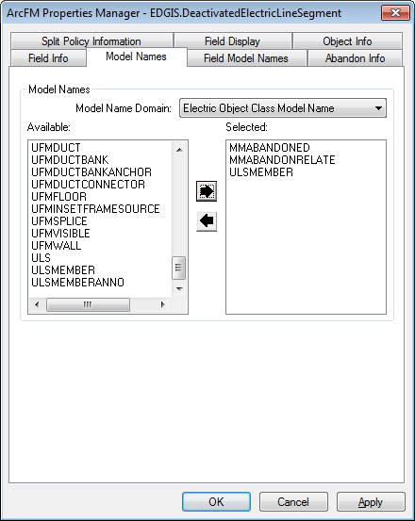

1. On the Object Info tab, assign the ArcFM Check Cross Section to the On Feature Update event and click Apply.
2. On the Object Info tab, assign the ArcFM Remove Deleted ULSMember AU to the On Feature Delete event and click Apply

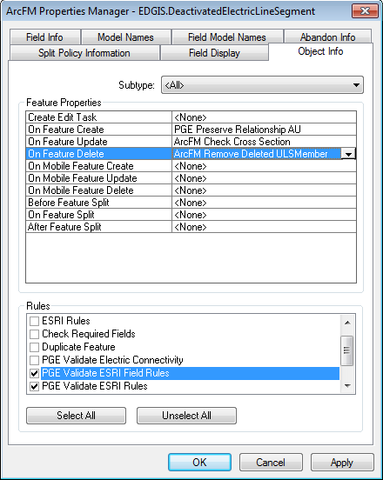

# Configure Annotation for Neutral and Deactivated Conductors

1. Right-click on the database level node and select “Properties…”

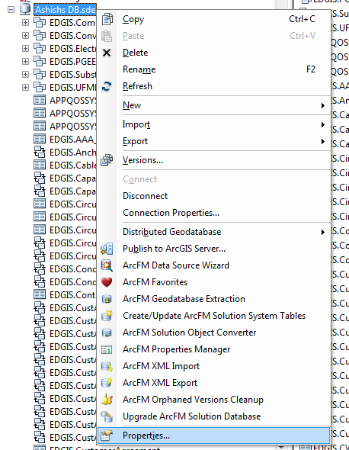

1. On the Domains tab, find the PGE ED Object Class Model Name Domain domain and enter a new value of PGE_NEUTRALCONDUCTOR at the end.

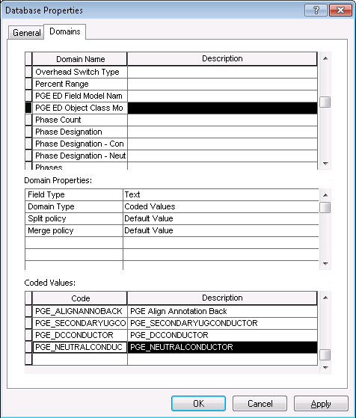

1. Enter a second value of PGE_DEACTIVATEDELECTRICLINESEGMENT and click OK.

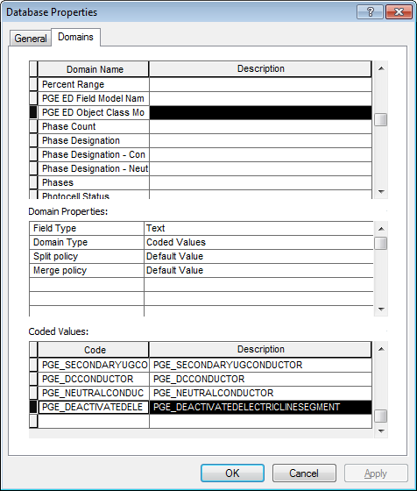

1. Right-click on the NeutralConductor feature class in the Electric dataset and select “Properties…”

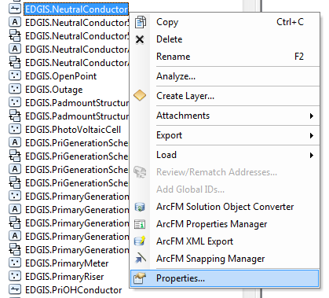

1. On the fields tab, add a new field with the following properties and click OK.
   1. Name: LABELTEXT2
   2. Alias: Cross Section Label
   3. Allow Null: Yes
   4. Type: Text
   5. Length: 100

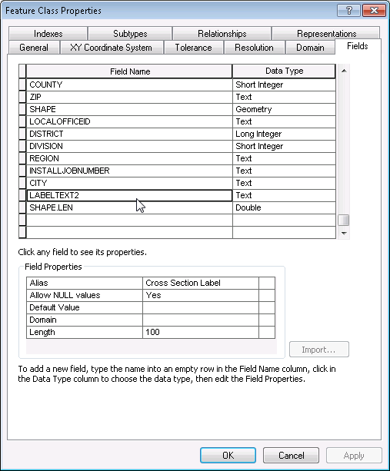

1. Right-click on the Neutral Conductor feature class in the electric dataset and select “ArcFM Properties…”.

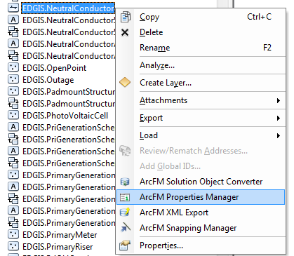

1. On the Class Model Names tab, add the PGE_NEUTRALCONDUCTOR model name and click Apply.

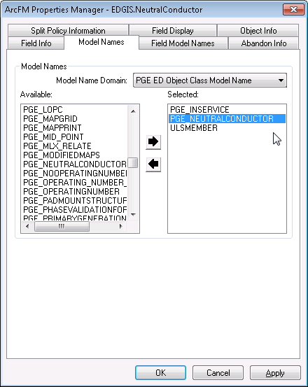

1. On the Field Model Names tab, find and select the LABELTEXT2 field and apply the ULSTEXTFIELD field model name.

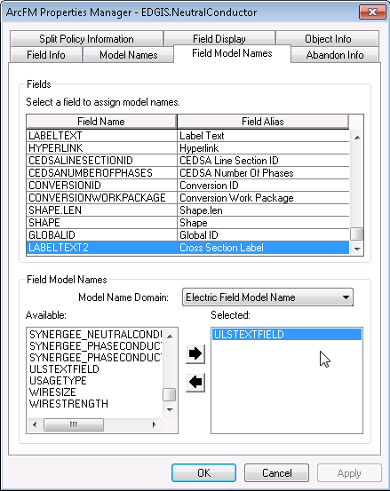

In addition, assign the following field model names:

|  |  |
| --- | --- |
| **Field Model Name** | **Field** |
| PGE_CONDUCTORSIZE | Conductor Size |
| PGE_CONDUCTORUSE | Conductor Use |
| PGE_CONDUCTORMATERIAL | Material |
| PGE_CONDUCTORCOUNT | Conductor Count |

1. On the Object Info tab, select the On Feature Create event, select Multiple and add the PGE Cross Section Conductor Anno AU to the end of the list. Click OK.

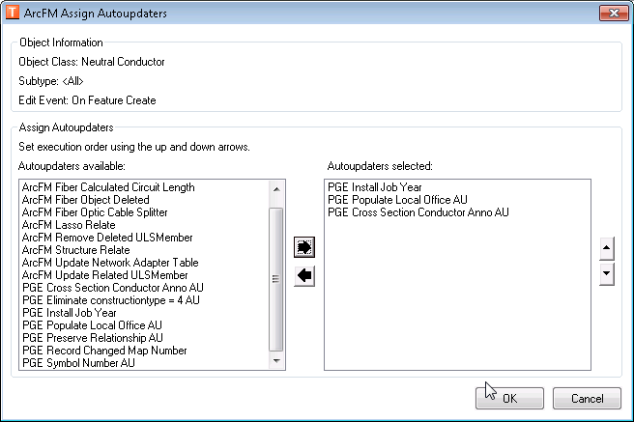

1. Still on the Object Info tab, select the On Feature Update event, select Multiple and add the PGE Cross Section Conductor Anno AU. Then move the ArcFM Check Cross Section AU down below the PGE Cross Section Conductor Anno AU. Click Apply. End result:

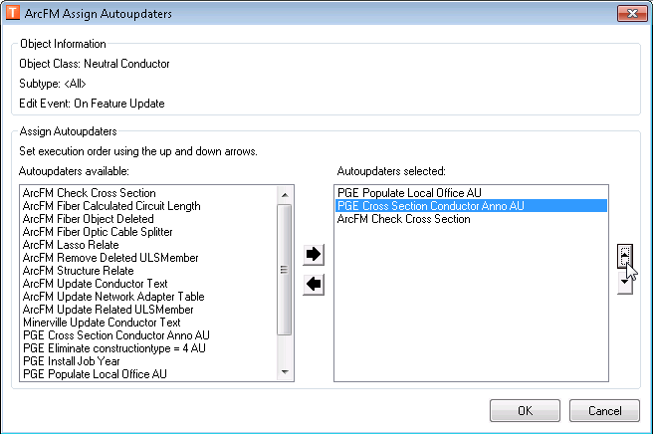

1. On the Object Info tab again, select the On Feature Delete event and add the ArcFM Removed Deleted ULS Member AU. Click OK.

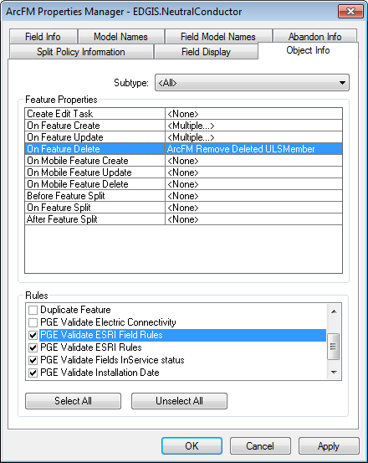

1. Right-click on the DeactivatedElectricLineSegment in the Electric Dataset and select “Properties…”

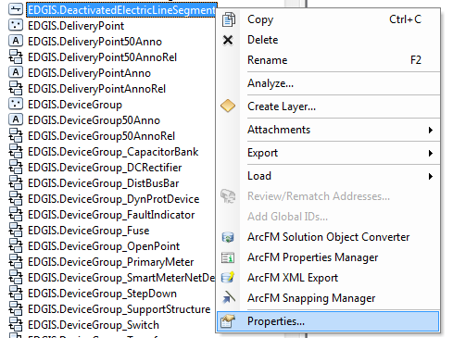

1. On the fields tab, add a new field with the following properties and click OK.
   1. Name: LABELTEXT
   2. Alias: Cross Section Label
   3. Allow Null: Yes
   4. Type: Text
   5. Length: 100

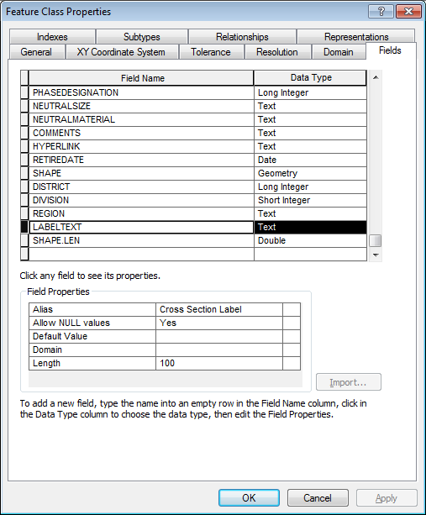

1. Right-click on the DeactivatedElectricLineSegment feature class in the electric dataset and select “ArcFM Properties…”.

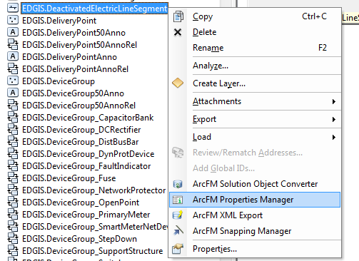

1. On the Class Model Names tab, add the PGE_DEACTIVATEDELECTRICLINESEGMENT model name and click Apply.

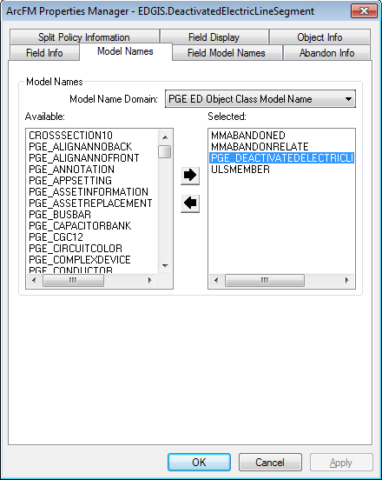

1. On the Field Model Names tab, find and select the LABELTEXT field and apply the ULSTEXTFIELD field model name.

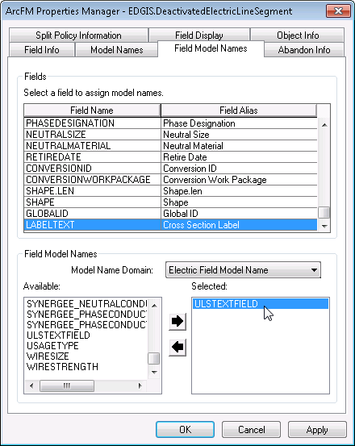

1. On the Object Info tab, select the On Feature Create event, select Multiple and add the PGE Cross Section Conductor Anno AU to the end of the list. Click OK.

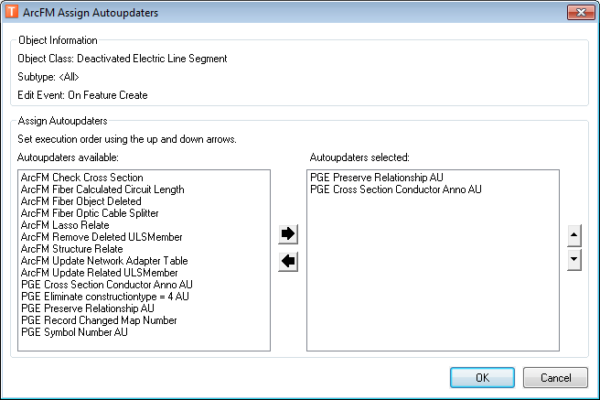

1. Still on the Object Info tab, select the On Feature Update event, select Multiple and add the PGE Cross Section Conductor Anno AU. Then move the PGE Cross Section Conductor Anno AU above the ArcFM Check Cross Section AU. Click OK.

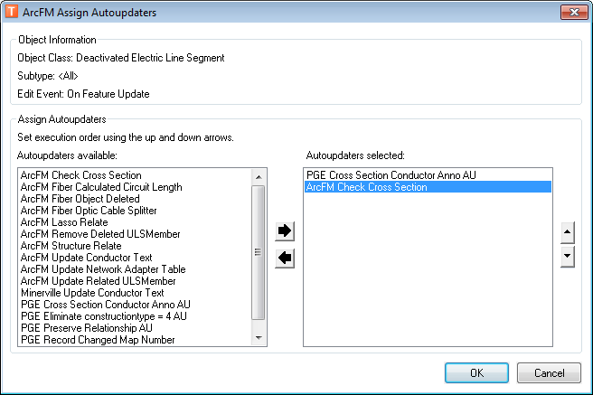

1. On the Object Info tab again, select the On Feature Delete event and add the ArcFM Removed Deleted ULS Member AU. Click OK.

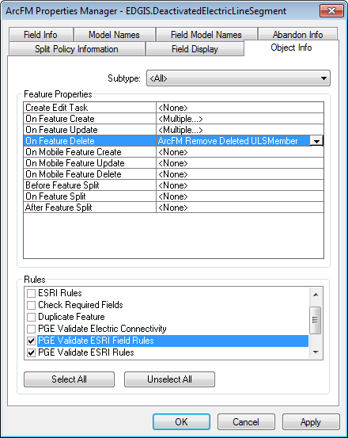

# 16529 - Move Position Description to Device Group

1. Right-click on the DeviceGroup feature class in the Electric Dataset and select “Properties…”

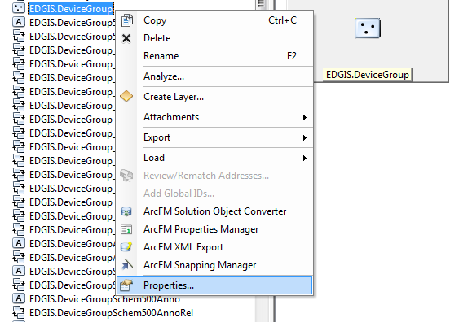

1. On the Fields tab, add a new field with the following definition:
   1. Name: POSITIONDESCRIPTION
   2. Data Type: Text
   3. Alias: Position Description
   4. Allow Null: Yes
   5. Length: 50

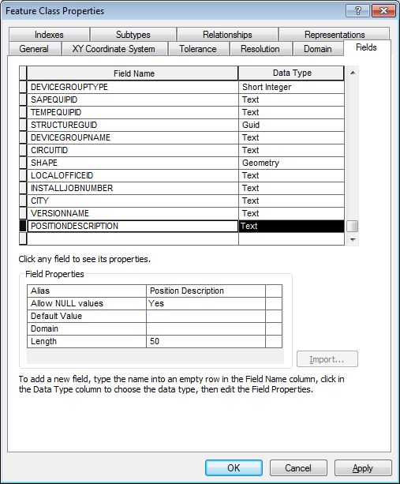

1. Click on OK.
2. Right-click on the TransformerUnit object table and select “Properties…”
3. On the Fields tab, find the existing POSITIONDESCRIPTION field and remove it.

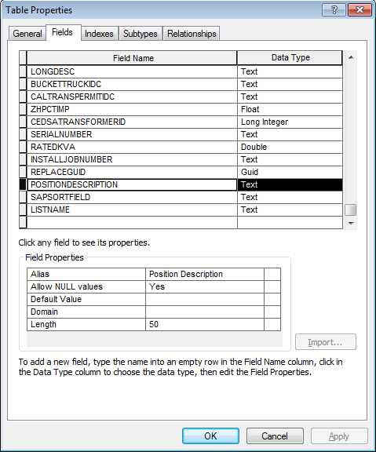

1. Click on OK
2. Right-click on the Electric Dataset and select New->Relationship Class
3. Enter a name of DeviceGroup_NetworkProtector and select DeviceGroup for the Origin class and NetworkProtector for the destination class

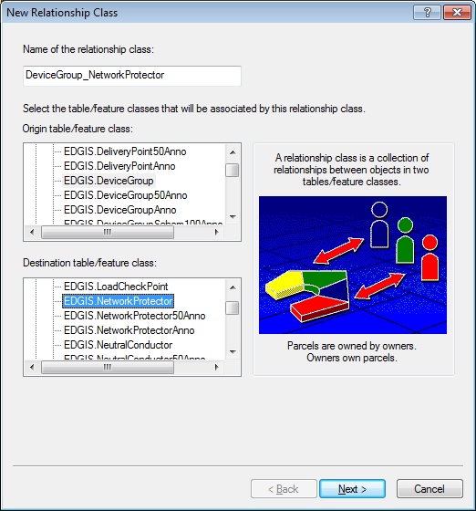

1. This will be a simple relationship

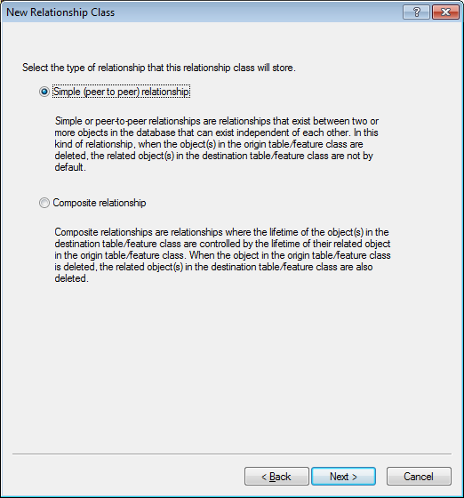

1. Provide labels of “Network Protector” and “Device Group” respectively and specify no messages

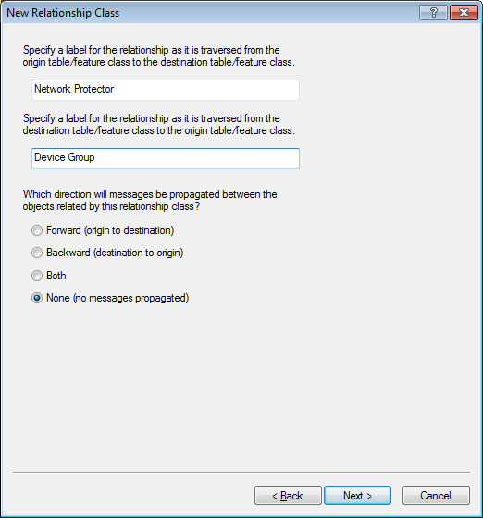

1. This relationship will be a 1-M

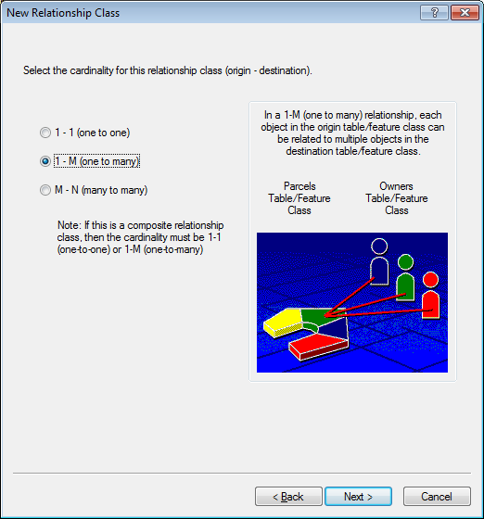

1. No additional attributes will be added

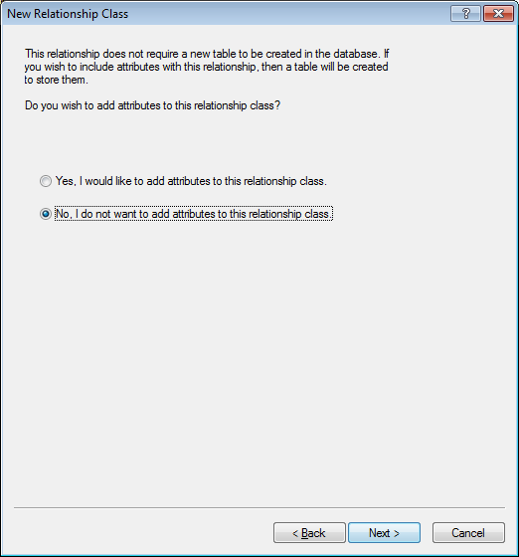

1. Specify GLOBALID for the origin primary key and STRUCTUREGUID for the destination foreign key

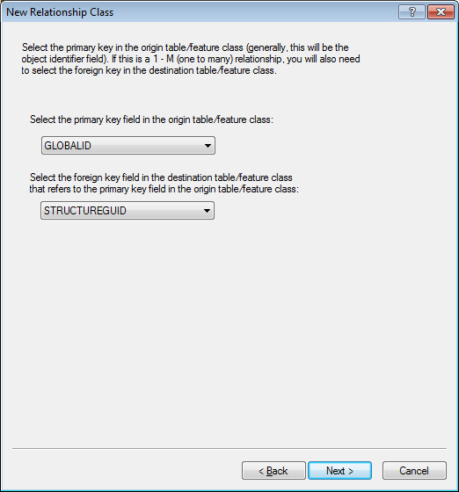

1. Review the Summary and click Finish

# Update the Primary Voltage domain

1. Right click the database and select Properties.

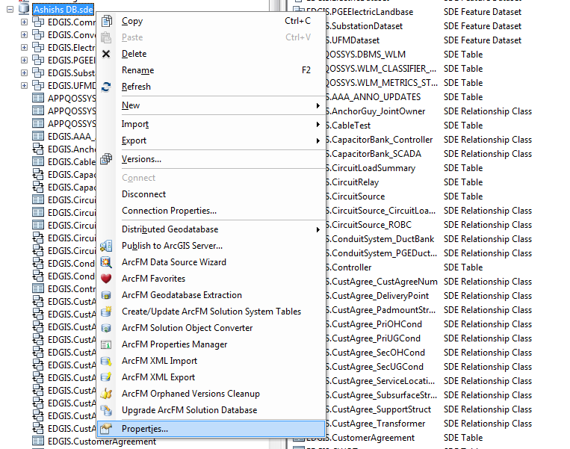

1. Find the Primary Voltage domain and update the descriptions as follows:

480 V = 480V

2.4 kV = 2kV

4.16 kV = 4kV

4.8 kV = 5kV

7.2 kV = 7kV

12.0 kV = 12kV

17.2 kV = 17kV

21 kV = 21kV

22 kV = 22kV

19.9 kV = 20kV

44.0 kV = 44kV

34.5 kV = 35kV

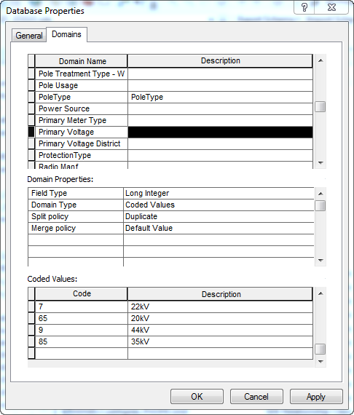

1. Click on OK

# 14560 - R3_BAY: PAR #61652 -- T-Connector (Open Point Subtype)

1. Double click the Open Point feature class to open its properties.
2. Select the Subtypes tab.
3. Select the Load Break Elbow, and then scroll to the bottom of the list. Make sure not to click anything else because the new subtype created will be based off of the last subtype clicked.
4. Add in the new subtype, Code=12, Description=”T Connector”.  
   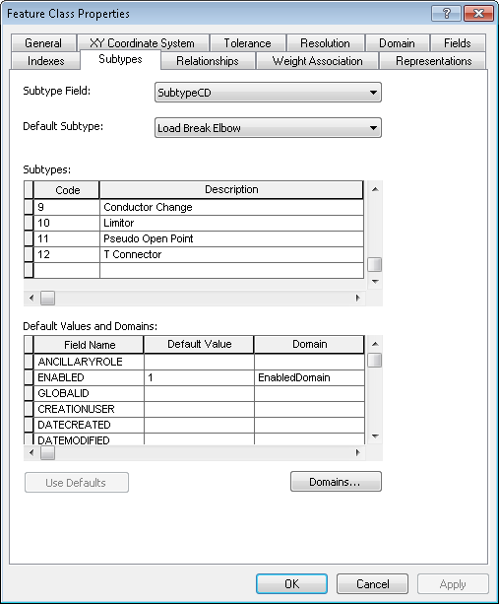
5. Select OK to accept.

# 16514 - R3_BAY: Load Point To Service Location

## Create TRANSFORMERGUID Field

* 1. Create field TRANSFORMERGUID inside the Secondary Load Point feature class.
     1. Double click the feature class to open Properties and select the Fields tab.
  2. Type GUID, Alias: Transformer GUID

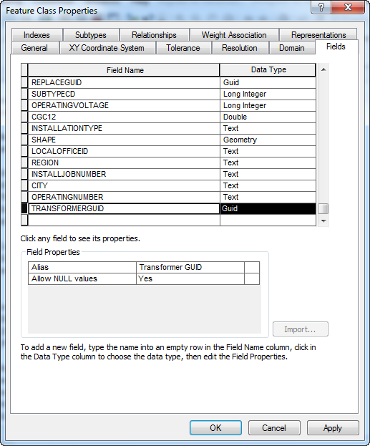

## Create Relationship Class Between Transformer and Secondary Load Point

1. Right click inside the Electric Dataset and select New->Relationship class.
2. Follow the below screens to create the relationship class.

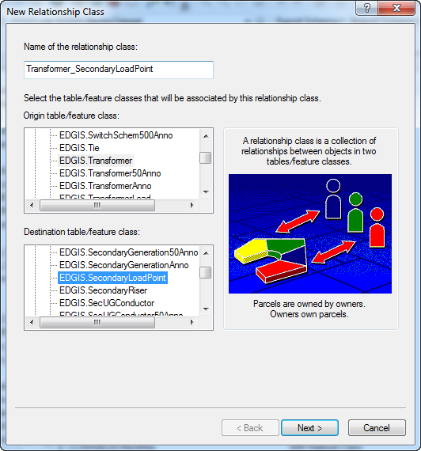

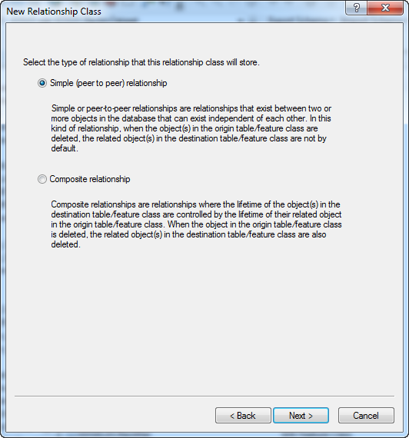

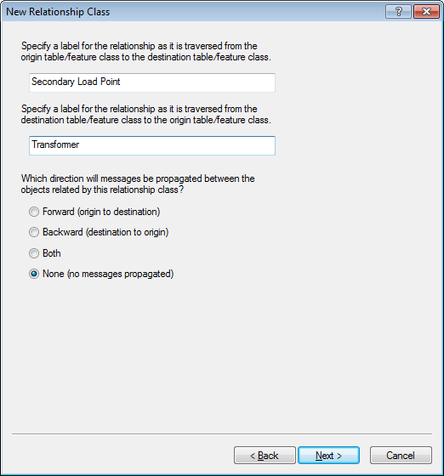

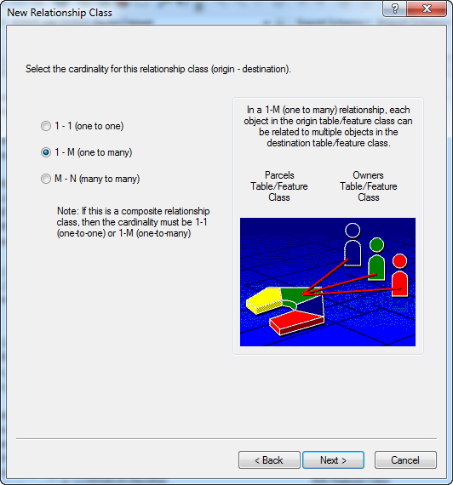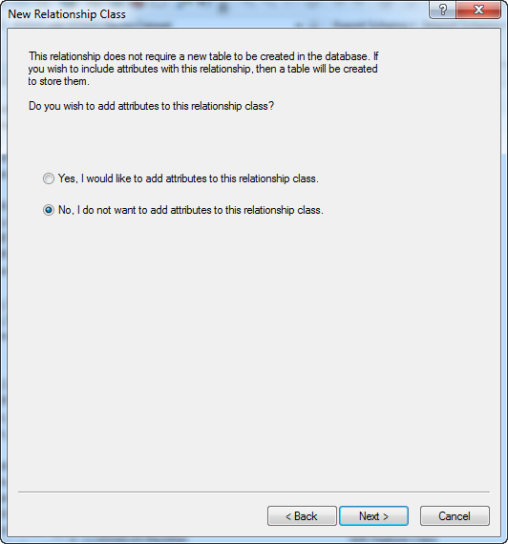

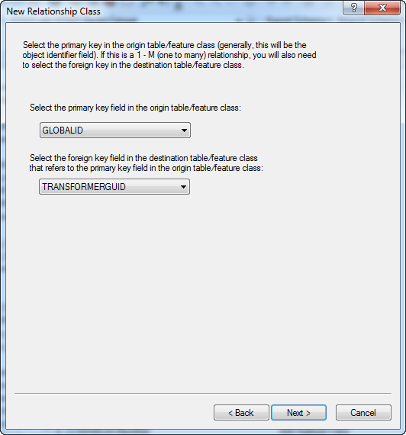

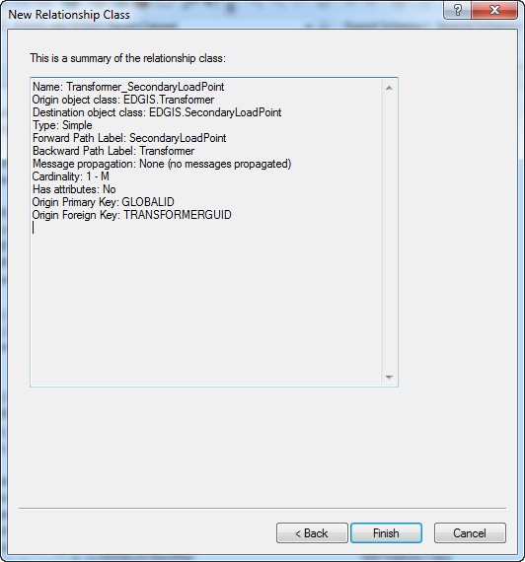

## Create SECONDARYLOADPOINTGUID Field

* 1. Create a new field in the Service Location feature class.
     1. Double click the feature class and select the Fields tab.
  2. Field SECONDARYLOADPOINTGUID, type Guid, Alias: Secondary Load Point GUID

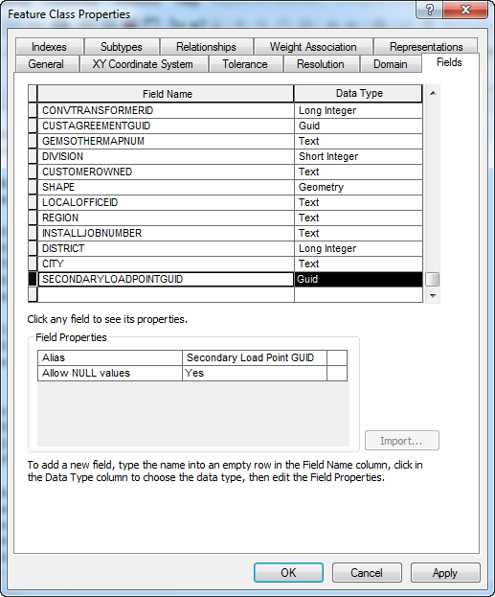

## SLP->SL Relationship

* 1. Right click in the ElectricDataset and select New->Relationship Class.
  2. Follow the below screens to create the relationship between Secondary Load Point and Service Location.

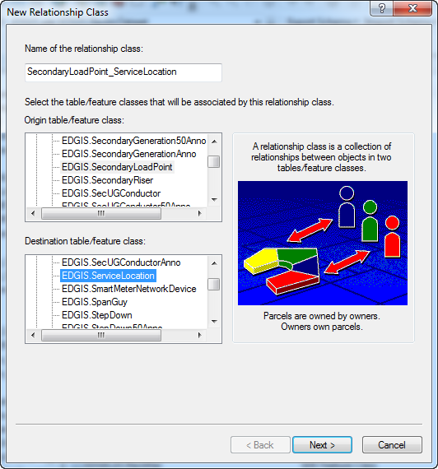

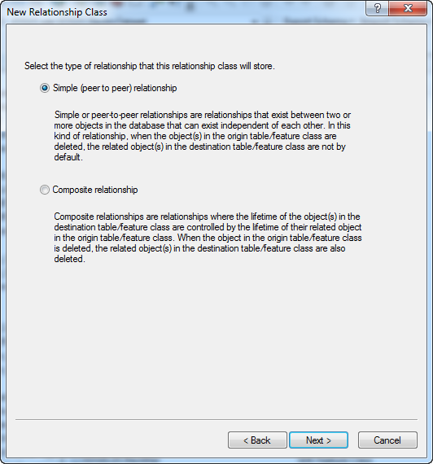  
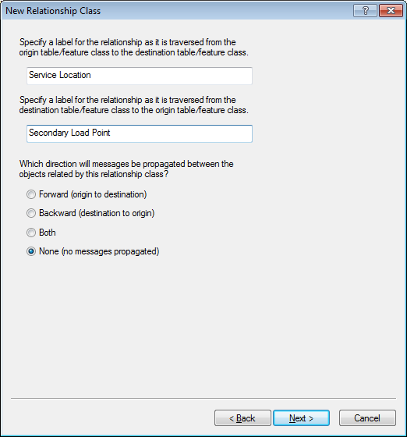

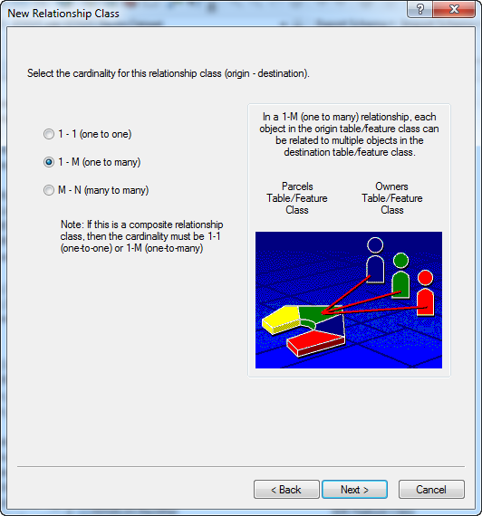

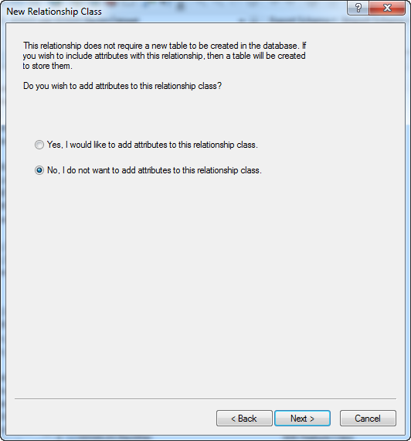

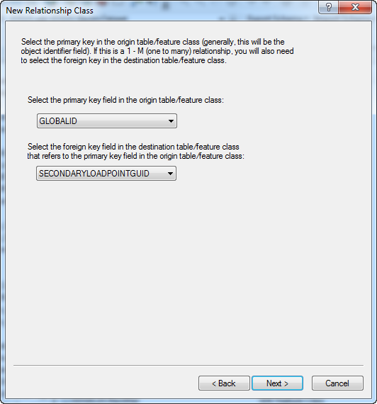

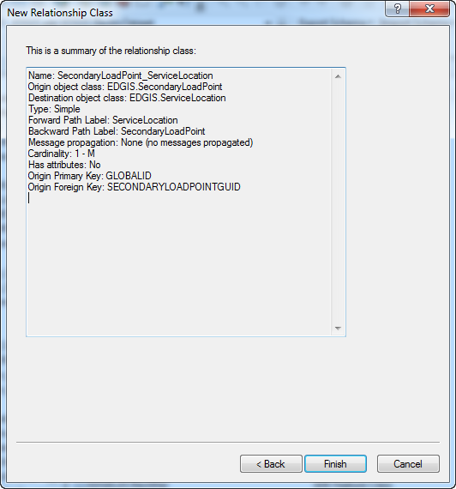

# Configure Neutral and Deactivated Conductor for UFM

1. Right-click on the database level node and select New->Relationship Class

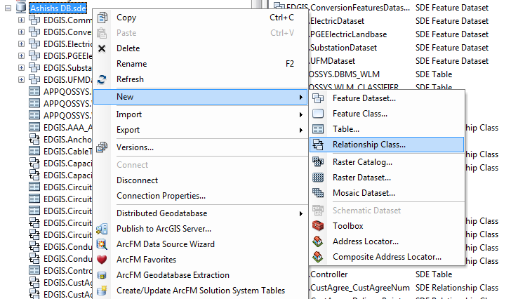

1. Enter a name of NeutralConductor_Duct and select the Neutral Conductor feature class for the source and Duct for the destination

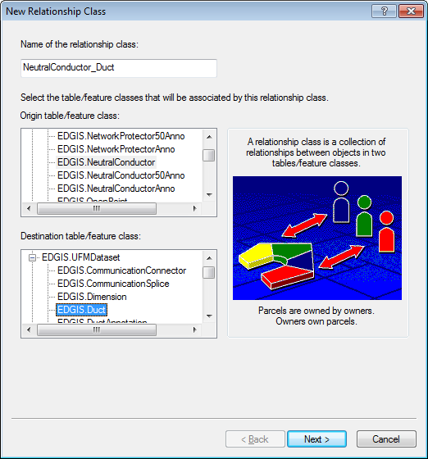

1. Specify a simple relationship

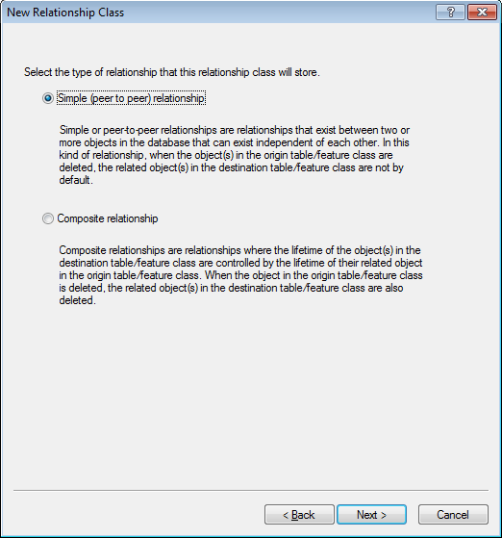

1. Specify “Duct” and “Neutral Conductor” as the traverse labels and ‘None’ for messaging

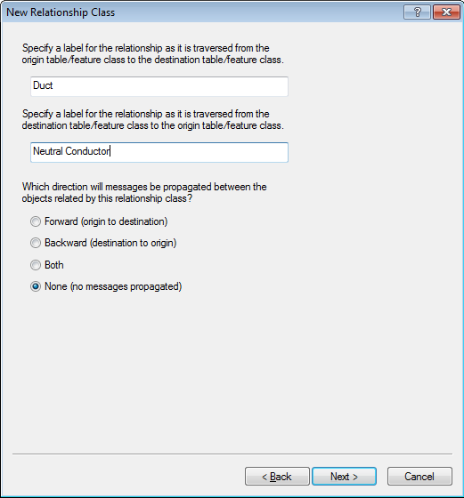

1. This relationship is an M-N relationship

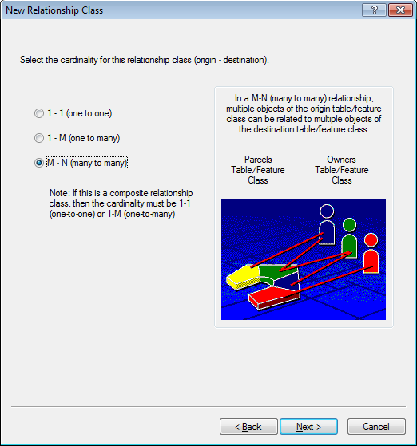

1. We will need to add attributes to this relationship

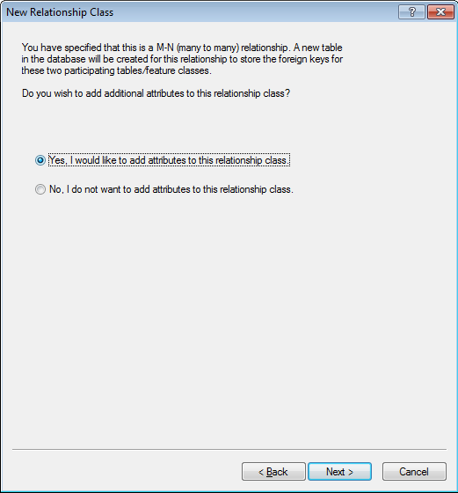

1. Add an attribute called PHASEDESIGNATION of type Long Integer

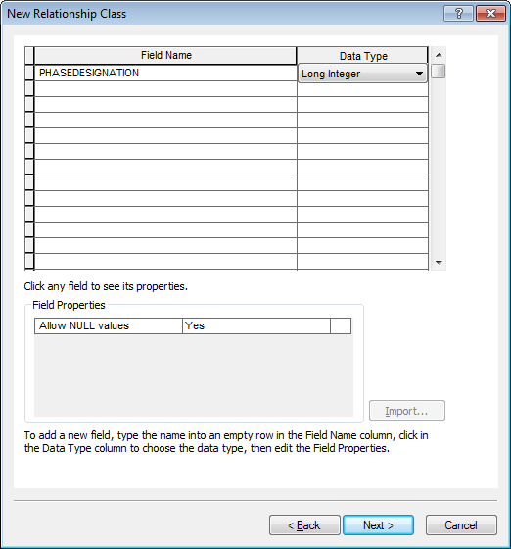

1. Leave the primary keys as OBJECTID and specify “NeutralConductorOID” and “DuctObjectID” for the foreign key

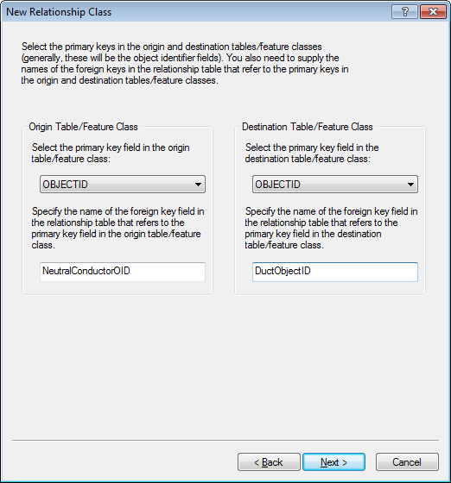

1. Review the summary and click “Finish”

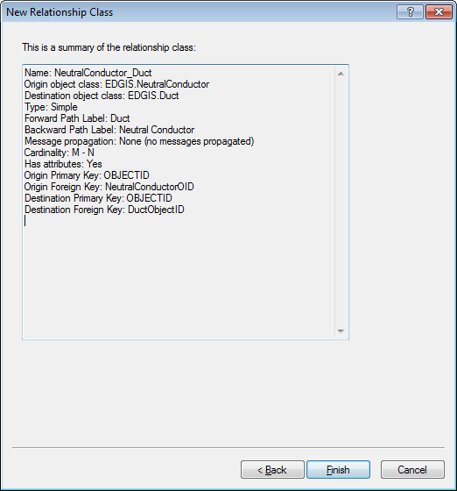

1. Right-click on the newly created relationship class and select “ArcFM Properties Manager”

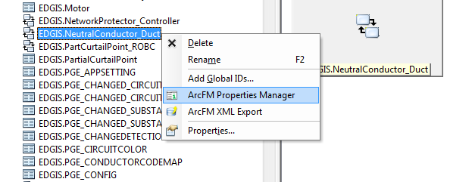

1. Assign the “ArcFM UFM Duct to Conductor Relationship AU” to all three events

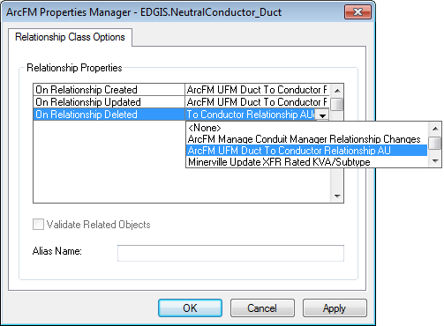

1. Right-click on the database level node and select New->Relationship Class



1. Enter a name of DeacElecLineSeg_Duct and select the DeactivatedElectricLineSegement feature class for the source and Duct for the destination

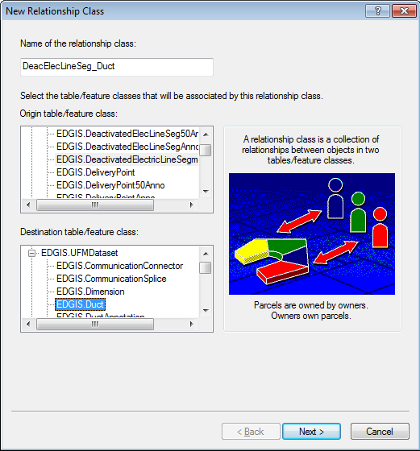

1. Specify a simple relationship



1. Specify “Duct” and “Deactivated Electric Line” as the traverse labels and ‘None’ for messaging

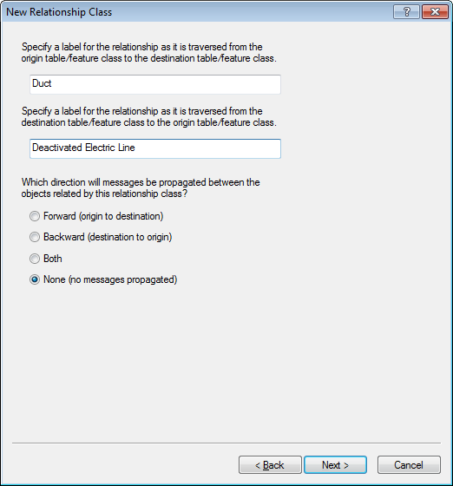

1. This relationship is a M-N relationship



1. We will need to add attributes to this relationship



1. Add an attribute called PHASEDESIGNATION of type Long Integer



1. Leave the primary keys as OBJECTID and specify “DeacElecLineSegOID” and “DuctObjectID” for the foreign key

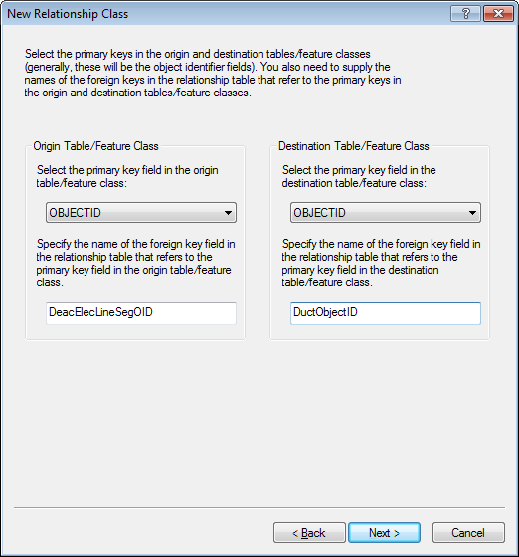

1. Review the summary and click “Finish”

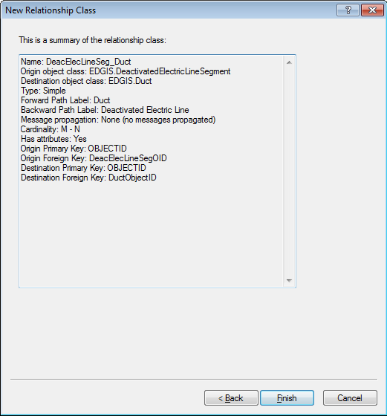

1. Right-click on the newly created relationship class and select “ArcFM Properties Manager”

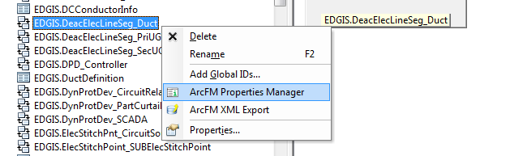

1. Assign the “ArcFM UFM Duct to Conductor Relationship AU” to all three events

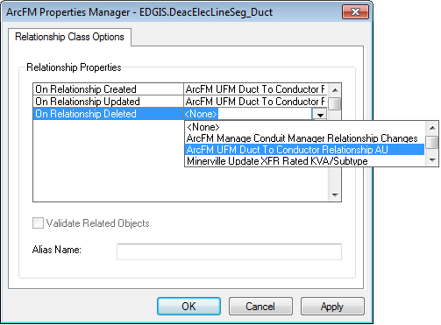

1. Add GlobalID by right clicking the new NeutralConductor_Duct relationship class and clicking “Add Global IDs…”
2. Click “Yes”

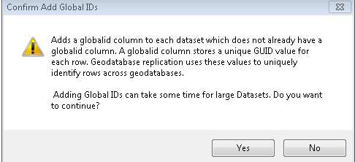

1. Observe GLOBALID has been added to the relationship class.
   1. If you get the following error message:  
      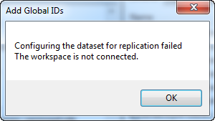
   2. Select the relationship class (NeutralConductor_Duct) and move it into the ElectricDataset.
   3. Right click the ElectricDataset and select “Add Global IDs…”
   4. When the operation is complete, select the NeutralConductor_Duct relationship class in the ElectricDataset and drag it back into the root level.  
      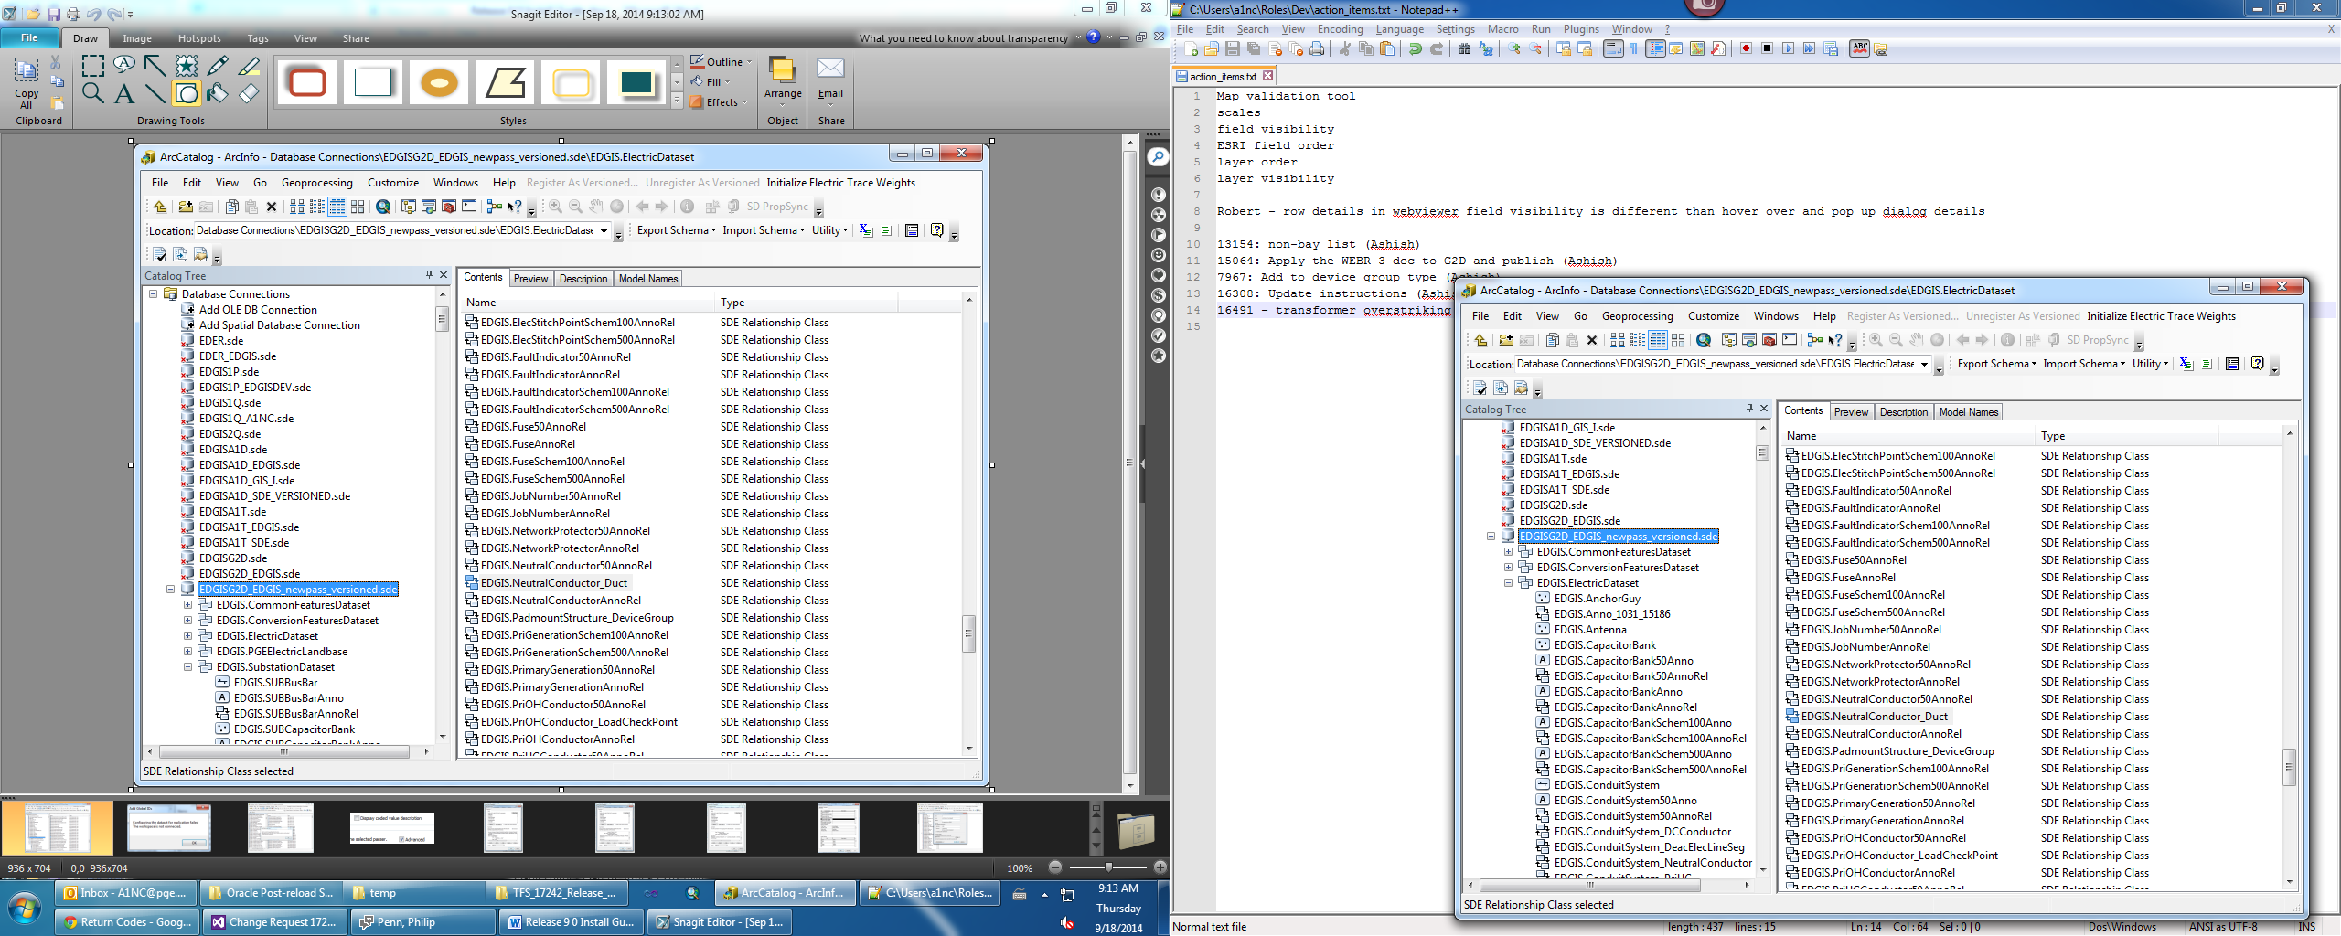
2. Repeat steps 23-25 on the DeacElecLineSegment_Duct relationship class

# Add Encasement Size to Conduit

1. Right-click on the ConduitSystem feature class in the Electric dataset and select “Properties…”

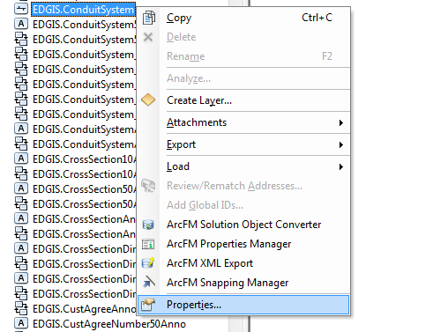

1. On the Fields tab, add a new field with the following attributes:
   1. Name: ENCASEMENTSIZE
   2. Type: Short Integer
   3. Alias: Encasement Size
   4. Allow NULL Values: Yes
   5. Precision: 3

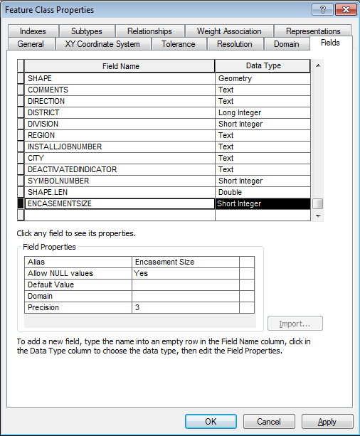

# Add New Device Group Type

1. Right-click on the Database level node and select “Properties…”
2. On the domains tab, find the “Device Group Type – Subsurface” domain and enter a new line item as follows:
   1. Code: 34
   2. Description: TGRAM (Two Way)

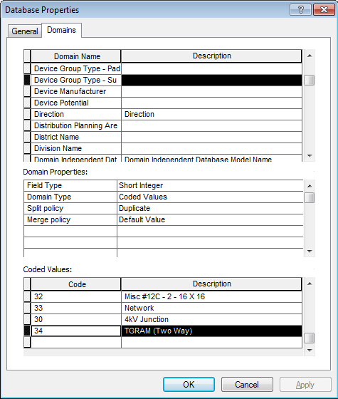

1. Click OK

# 7967 - R3_BAY: PAR 20907: Distribution Subsurface Transformer Device Group Structure Type Name Not In Drop Down

1. Right click the database and select Properties.

In the Domains tab, locate the “Device Group Type – Subsurface” domain and add the following code/value:  
35/Subsurface Triplex Transformer  
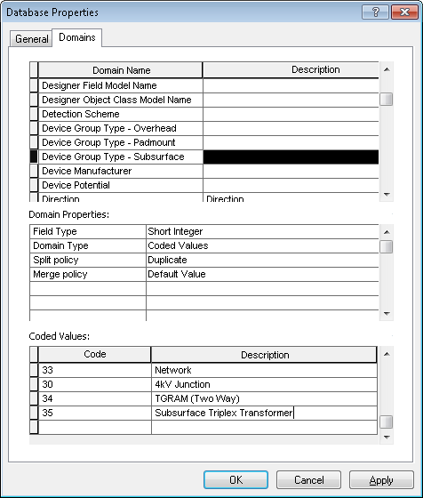

1. Select the Device Group Type – Padmounted domain above it and scroll to the bottom of the codes/values.
2. Add the following new code/value:  
   48/Padmounted Triplex Transformer  
   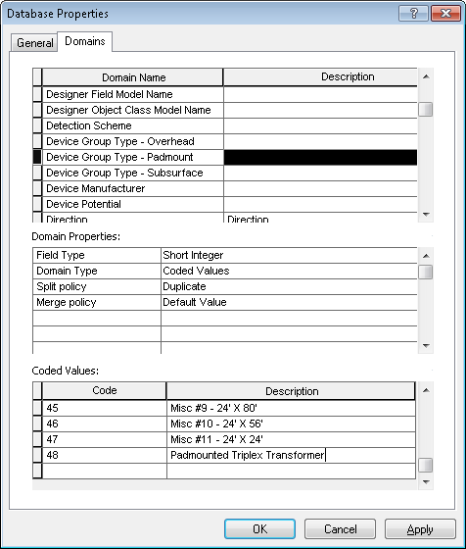
3. Select OK.

# R3_BAY: PAR 64063: Transformer Overstriking in SFO

Note: Perform any steps that have not yet been performed and skip the steps that have already been performed.

1. Right click the database and select the Domains tab.
2. Add a new domain:  
     
   Name: SymbolSpace

Field Type: Long Integer

Domain Type: Range Domain  
Minimum value: 1  
Maximum value: 3  
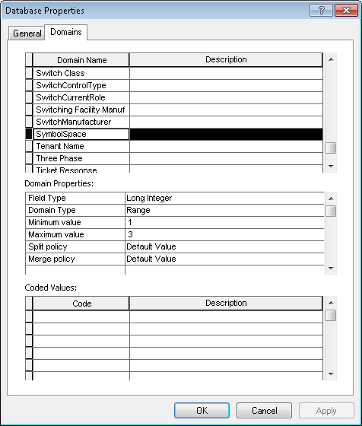

1. Double click the Transformer feature class and select the Fields tab.
2. Add a new field:  
     
   Name: SYMBOLSPACE  
   Type: Long Integer  
   Alias: Symbol Space  
   Allow Nulls: Yes  
   Precision: 5  
   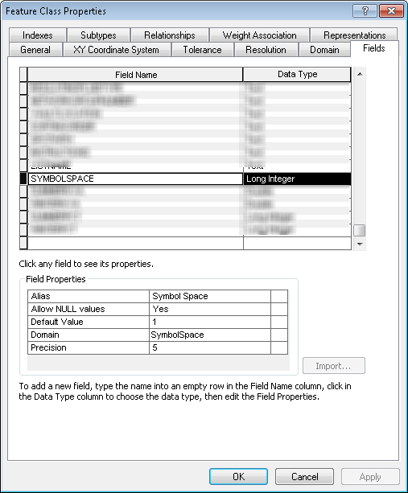
3. Click Apply.
4. Select the Subtypes tab and select the Distribution Overhead subtype.
5. In the fields list, scroll to the Symbol Space field and assign the SymbolSpace domain to it.
6. Set the default value to 1.  
   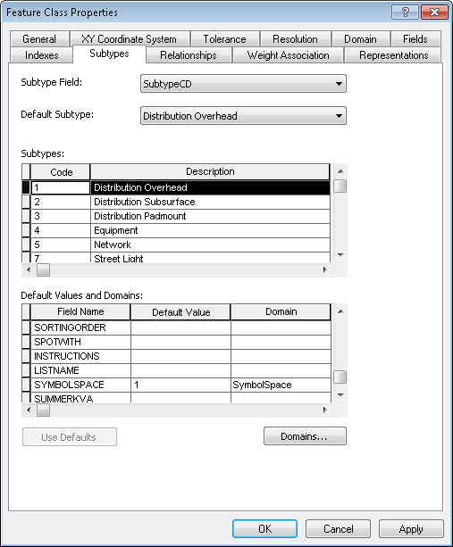
7. Repeat the above steps for Equipment, Network, and Streetlight subtypes.
8. For all other subtypes, set the domain to Not Applicable – Integer and the default value to 0.

# Add FacilityID to UFM Feature Classes

1. Right-click on the Dimension feature class in the UFM dataset and select Properties.
2. Add a new field with the following properties:
   1. Name: FACILITYID
   2. Alias: Facility ID
   3. Allow NULL Values: Yes
   4. Data Type: Text
   5. Length: 50

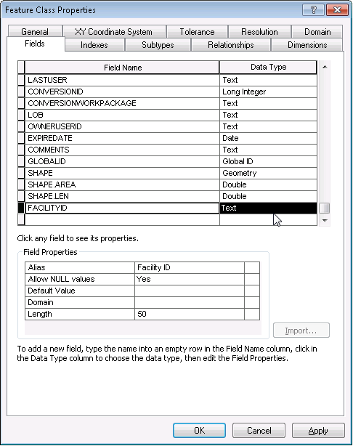

1. Right-click on the Dimension feature class and select ArcFM Properties
2. On the Field Model Names tab, assign the FACILITYID field model name to the Facility ID field.

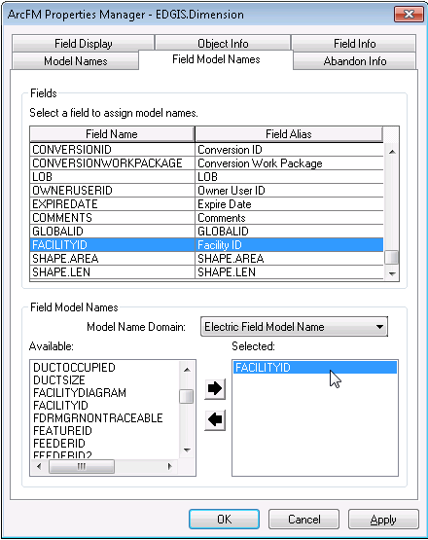

1. Repeat steps 1 through 4 for the following feature classes:

* CommunicationSplice
* Duct
* DuctAnnotation
* DuctNoteAnno
* UGElectricSplice
* CrossSection10Anno (Electric dataset)

# Set permissions on root level items

1. Select the ArcToolbox button from the Standard toolbar.
2. Expand Data Management Tools, expand Database, and select Change Privileges.  
   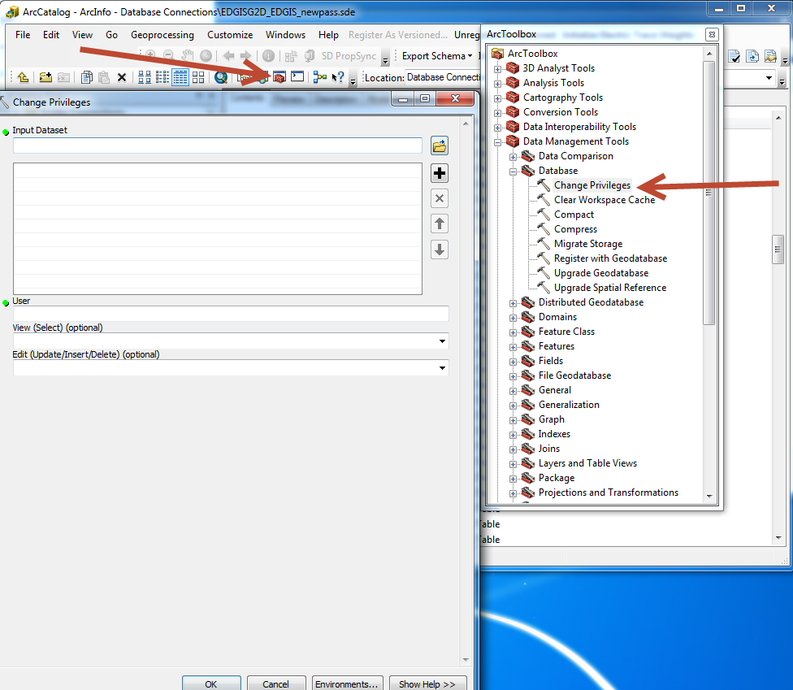
3. Select the folder icon next to the Input Dataset field, select the target SDE file, and select the following objects to add from the root level:
   1. EDGIS.CustAgree_DeliveryPoint
   2. EDGIS.CustAgree_PadmountStruct
   3. EDGIS.CustAgree_PriOHCond
   4. EDGIS.CustAgree_PriUGCond
   5. EDGIS.CustAgree_SecOHCond
   6. EDGIS.CustAgree_SecUGCond
   7. EDGIS.CustAgree_ServiceLocation
   8. EDGIS.CustAgree_SubsurfaceStruct
   9. EDGIS.CustAgree_SupportStruct
   10. EDGIS.CustAgree_Transformer
   11. EDGIS.DeacElecLineSeg_Duct
   12. EDGIS.NeutralConductor_Duct
   13. EDGIS.CustomerAgreement
4. Using the below table, assign permissions as follows one at a time. Repeat for all 7 roles.

SDE_EDITOR

DAT_EDITOR

DATACONV - select only

DMSSTAGING - select only

SDE_VIEWER - select only

GIS_INTERFACE - select only

GISINTERFACE - select only  
  
Example:  
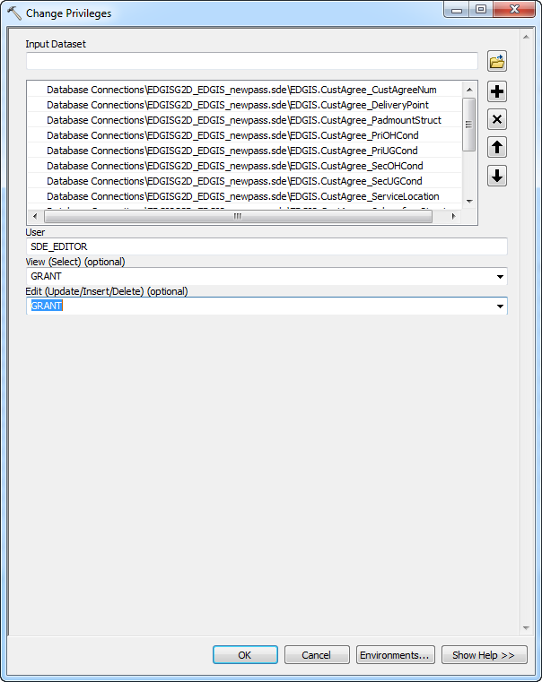

# Update Data Model Version Table

**Database Configuration:**

1. Open SQL Plus.
2. Log in using the same server and user as was used in section 2.  
     
   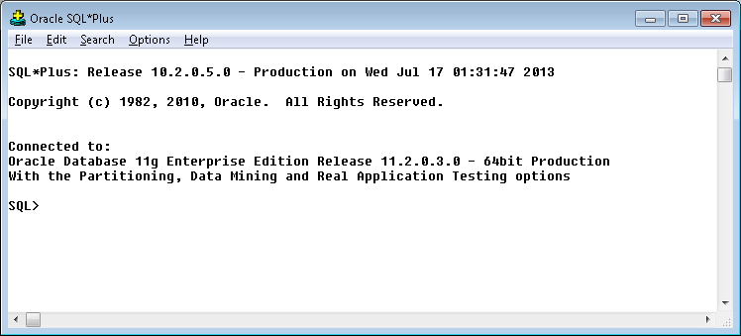
3. Run the SQL below:

update edgis.pgedatamodelversion set currentidc='N' where currentidc='Y';

insert into edgis.pgedatamodelversion (OBJECTID, CURRENTIDC, DATEAPPLIED, APPLIEDBYPERSONNAME, MODELVERSION) values (**<*max(objectid) + 1*>**,'Y',sysdate,'**<*INSERT TEAM MEMBER DONE BY*>**','**9.0** GOLD');

commit;

# Known Issues

<Please List any other issues encountered here while following the document>